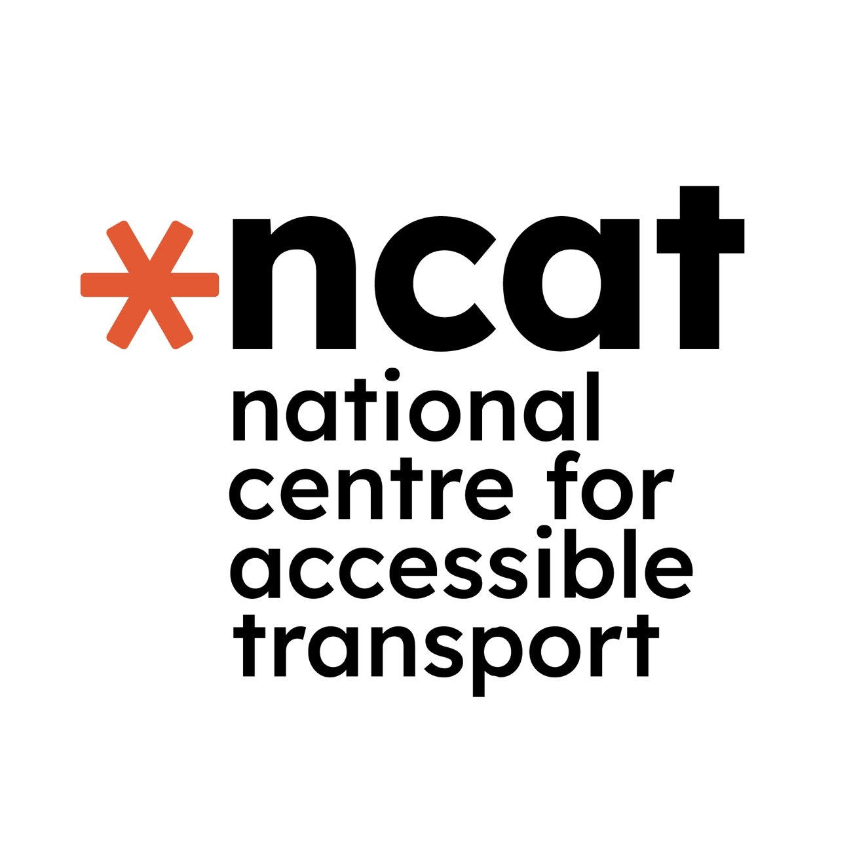

Governance Board Member required for National Centre for Accessible Transport

If you require this document in another format please email info@ncat.uk or leave a voice message on 024 7765 1808

Application deadline: 5pm - Wednesday 30 September 2026

What we are looking for:
An individual who has expertise in transport accessibility coupled with a lived experience of disability to join the Governance Board of the National Centre for Accessible Transport (ncat).

What you will do:
You will provide strategic governance and oversight of ncat’s programme of work, attending Board meetings at least four times a year, as well as an annual Board Awayday. You will review and scrutinise Board papers, provide constructive challenge and guidance, and bring your expertise, knowledge and perspective to Board discussions and decision-making.

There will also be time required between meetings for reading, preparation and follow-up, which can take place online or by email. Depending on your interests, skills and availability, you may also have opportunities to undertake additional Board-related activity, such as participating in working groups, by mutual agreement.

What experience you will have:
A high level of skill or knowledge in at least one area of transport (road, rail, sea, or air), and/or an in-depth knowledge of the trade and transport ecosystem, accessibility and how delivery works for disabled people, and your own lived experience of disability.

How long will this role last:
For the remainder of the current funded period (to December 2029), subject to a 6-month probationary period.

Accessibility and adjustments:
Accessibility is central to how we work. We recognise that recruitment processes can create barriers to participation, and we are committed to identifying and removing or reducing those barriers wherever possible.

Our application and interview processes can be adapted to support accessible and inclusive participation. If an adjustment or alternative approach would help remove a barrier at any stage of the recruitment process, please contact us to discuss this.

This approach regarding supporting adjustments will also apply to participation in Board meetings, or other meetings or engagements.
For queries about accessibility or adjustments, please email info@ncat.uk or leave a voice message on 024 7765 1808. Our Centre Manager will get back to you.

About the National Centre for Accessible Transport:
The National Centre for Accessible Transport (ncat) is an independent evidence centre established in 2023. It is funded through a £20 million, seven-year grant from the Motability Foundation and delivered by a consortium including Coventry University, Connected Places Catapult, Designability, Policy Connect, the Research Institute for Disabled Consumers (RiDC) and WSP.
ncat equips government, transport operators, service providers and other stakeholders to remove transport barriers and create accessible journeys for everyone.
It brings together evidence, lived experience and innovation to strengthen understanding, inform decision-making and drive long-term systemic change.

ncat’s work helps to shape a transport system that is accessible, inclusive and works for everyone.

The opportunity:
The National Centre for Accessible Transport (ncat) is seeking to appoint a D/deaf, disabled or neurodivergent person with expertise in transport accessibility to join its Governance Board, bringing additional expertise, knowledge and lived experience to complement and strengthen the Board’s existing skills and perspectives.

This opportunity has arisen following the retirement of one of the Board’s founding independent members. The successful candidate will contribute as an independent Board member, working alongside the five other independent Board members and six senior representatives from the ncat Consortium. The Board is led by its independent Chair.

We are particularly interested in receiving applications from people who bring expertise in transport accessibility and can contribute their knowledge, experience and perspective to ncat’s governance and strategic direction.

Board members provide strategic oversight and direction of ncat’s work. Collectively, the Board is responsible for monitoring ncat’s performance and operations, including financial management, delivery, monitoring and evaluation. It provides oversight of strategic risks and challenges, supports their mitigation, and agrees strategic financial expenditure.

The Board, through its independent Chair, reports regularly to ncat’s funder, the Motability Foundation. It also receives insight and challenge from ncat’s Expert Panel, which brings together expertise from transport, charitable organisations, Disabled People’s Organisations (DPOs) and policy.

The successful candidate will bring their professional expertise, knowledge and lived experience to ncat’s governance and strategic direction. Their perspective will contribute to ensuring that accessibility and the experiences of D/deaf, disabled and neurodivergent people remain central to ncat’s work.

The role is remunerated in recognition of the time, commitment and expertise required. While the role is funded, it is an independent Board position, and remuneration is not conditional on any expectations beyond active participation in the role.

The role:
The Board meets at least quarterly, either online or in person, with hybrid arrangements available where appropriate. In-person meetings will be held at venues in locations across the country.

Board papers are circulated in advance and provided in a range of formats where required, enabling members to prepare fully for meetings. Meetings are scheduled for sufficient time to enable the Board to scrutinise and discuss reports, ask questions, provide feedback and guidance, and contribute relevant expertise, knowledge and insight to ncat’s work.

The Board also considers the impact of ncat’s work and outputs, and makes recommendations on opportunities for further connection, collaboration and dissemination. Board members may also act as ambassadors for ncat where appropriate.

The role is expected to commence in Autumn 2026 and will run until the end of the current funded period in December 2029. A six-month probation period will apply. An induction will be provided before the first Board meeting.

Board meetings are generally scheduled for the third Tuesday of every third month

The current meeting dates for the next period are:
- Tuesday 03 November 2026 — in person, venue to be confirmed
- Tuesday 19 January 2027 — online
- Tuesday 20 April 2027 — in person, venue to be confirmed
- Tuesday 20 July 2027 — online
- Tuesday 26 October 2027 — online
- Tuesday 25 January 2028 - online

Remuneration:
This role is a renumerated position, and Board members will be recompensed directly by lead partner of ncat, Coventry University. Board members will however be independent, and impartiality from Coventry University will be assumed and retained. They will not be treated as employees of the University, nor will any employee benefits be applicable. Board members are engaged via a contract for services (rather than a contract of employment).

The form of recompense and type of formal engagement will depend on the individual’s personal tax status; members will either be contracted as an external consultant/supplier (if self-employed or Director of a private company), or potentially recompensed under IR35 rules (which will include Tax and NI deductions being paid from the total on their behalf) if no suitable tax status applies.
IR35 definitions can be found at https://www.gov.uk/guidance/understanding-off-payroll-working-ir35

Each Board member will be recompensed for their participation and attendance up to a maximum of £6,000 per Annum (which will include personal Tax requirements as individually appropriate, but is not inclusive of VAT, where applicable), with reasonable travel expenses additionally re-imbursed.

If you require further clarification, please email info@ncat.uk or leave a voice message on 024 7765 1808 and the Centre Manager at ncat will get back to you.

Your experience:
Essential criteria - you must:
- have direct experience of working in or engagement with the transport sector on accessibility
- be disabled* (*as defined by the Equality Act 2010 as linked here https://www.gov.uk/definition-of-disability-under-equality-act-2010 )
- live in the UK (permanent residence)
- have a strong, wide-ranging understanding of transport issues nationally and the specific needs of disabled passengers and road users
- have a strong awareness of the wider social and economic issues faced by disabled people in the UK
- have experience of working with partners/stakeholders across multiple sectors, e.g., commercial, local authority, academic institutions, or not-for profit sectors
- have experience of working with Disabled People’s Organisations and/or support organisations
- have an understanding of good practice in involving D/deaf, disabled and neurodivergent people in the design and development of services, recognising the diversity of people’s experiences and the barriers created by systems, services and environments
- have experience of working on programmes or initiatives focused on accessibility, inclusion or removing barriers for D/deaf, disabled and neurodivergent people
- have experience of overseeing or contributing to large-scale programmes of work delivered over an extended period
- have an understanding of the challenges and opportunities organisations working with and within the transport sector face in improving accessibility and removing barriers to participation
- have an understanding of national and/or local government and transport operators, including their role as commissioners, providers or partners in the transport system
- be proactive, adaptable and able to navigate complexity, providing constructive challenge, insight and guidance across complex projects and programmes.

How to apply:
Please submit a CV or equivalent biographical information and a covering letter outlining your motivation for applying, and the skills, experience and knowledge you would bring to the role.
Please also provide details of at least one referee who we may contact.

We recognise that people may prefer or need different ways to demonstrate their experience and suitability. You may therefore submit your application in writing or, where appropriate, use an alternative format such as a video. We will consider applications based on the information provided, rather than the format used.

As guidance we suggest not more than 2 pages for your CV and not more than 1,500 words for a covering letter, or 5 minutes maximum for a video/audio submission.

If there are barriers to completing the application in the available formats, or you would like to discuss an alternative way of demonstrating your suitability, please contact Cathryn Thompson-Goodwin, ncat Centre Manager, at info@ncat.uk or leave a voice message on 024 7765 1808.

Deadline for application:

Applications must be received by 5pm on Wednesday 30 September 2026 by email to info@ncat.uk. Please use “ncat Board Member Application” as the subject line.
Initial interviews will be held online on either Tuesday 13th October (after 1pm) or Wednesday 14th October (between 10am and 4pm).
Interview dates and arrangements will be confirmed to shortlisted candidates.

We recognise that recruitment processes can create barriers to participation. We will work with shortlisted candidates to identify and, wherever possible, remove or reduce barriers to taking part in the interview process. Interviews can be adapted or alternative arrangements made where appropriate.

To discuss the interview process or any accessibility requirements, please contact Cathryn Thompson-Goodwin, ncat Centre Manager, at info@ncat.uk or leave a voice message on 024 7765 1808.

ncat is hosted by Coventry University, a Disability Confident Employer.
In line with the Disability Confident scheme, candidates who meet all the essential criteria will be guaranteed an interview.

National Centre for Accessible Transport (ncat)
National Transport Design Centre, Coventry University, Swift Road, Coventry, CV1 2TT
https://www.linkedin.com/company/ncat-uk/

www.ncat.uk

For any queries regarding the process of application please contact Cathryn Thompson-Goodwin (ncat Centre Manager) via info@ncat.uk or by leaving a voice message on 024 7765 1808

For any queries about this opportunity, please contact Dr Emma Partlow, CEO of ncat, via ceo@ncat.uk

