Accessible Transport:

Evidence to Inform Change

Three years of research from the National Centre for Accessible Transport

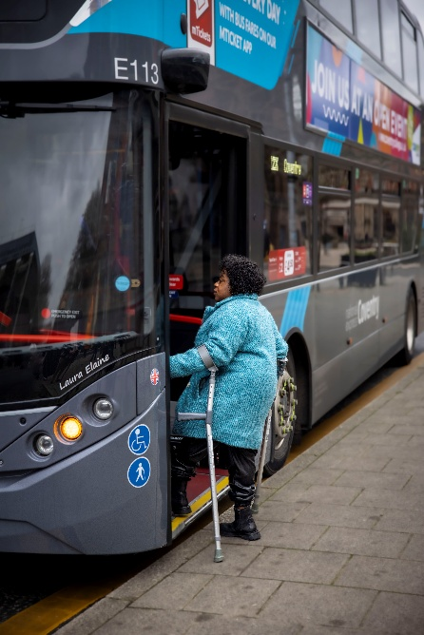

Contents
Executive summary 3
CEO Foreword, Emma Partlow Chief Executive Officer, National Centre for Accessible Transport 5
Language and approach 8
About ncat 9
Our funder, the Motability Foundation 10
Our consortium partners & supporters 12
Governance and expert input 13
Evidence shaped by lived experiences 14
ncat impact 15
Linking evidence to policy and practice 16
Transport innovations 17
Supersmith 19
Journeys across the transport system 20
Streetscapes as a barrier to accessible travel 21
Vehicles, stations and assistance 23
Information, data and predictability 25
Attitudes, behaviour and culture 27
Three years of evidence to inform change 29
Looking ahead 30
References and Further Reading 30
National Centre for Accessible Transport publications 30

Executive summary
Over its first three years, the National Centre for Accessible Transport (ncat) has established the UK’s first national evidence base, addressing a long-standing gap in how accessibility is experienced across the transport system. Funded by the Motability Foundation, ncat was created as an independent centre to equip stakeholders to remove transport barriers and create accessible journeys for everyone by bringing together evidence, lived experience, and innovation to drive long-term systemic change.
Since 2023, ncat has published 17 major research outputs spanning streets and pavements, vehicles and stations, information and digital tools, public attitudes, governance and decision-making, helping to build a more complete picture of how barriers arise in practice across the whole journey.
Disabled peoples lived experience has shaped every stage of this work. Over three years, 19 national surveys engaged 7,733 participants, supported by a Community of Accessible Transport (CAT) panel of more than 3,400 members, with over 8,600 people contributing to research and engagement activity overall. This evidence shows that barriers to accessible travel remain widespread and persistent: 92% of disabled people report barriers on at least one mode of transport, 79% travel less often because of those barriers, and 84% experience longer journey times.
The findings show that accessibility depends not on any single feature or mode, but on how reliably the entire transport system functions.
Working in partnership with think tank Policy Connect, ncat has translated this evidence into the Accessible Transport Charter, which sets out clear commitments for local and combined authorities to improve accessibility and strengthen accountability. Alongside this, the two organisations have established a Public Sector Community of Practice to support implementation, sharing best practice, resources and lived experience in response to identified gaps in funding, expertise and guidance. Extending this from policy into transport innovation, the Scaling Innovation programme supports innovators and SMEs to develop and test new approaches to transport accessibility, engaging with disabled people to ensure their experiences and expertise inform practical action.
Together, this work positions ncat as a national evidence centre driving more consistent, joined-up and evidence-led action to remove barriers and make transport accessible for everyone, contributing to improved accessibility and, in turn, better quality of life for disabled people.

CEO Foreword, Emma Partlow Chief Executive Officer, National Centre for Accessible Transport

The National Centre for Accessible Transport (ncat) was established to deepen understanding of how transport systems are experienced by disabled people, and how accessibility can be improved across the whole journey. Over the last three years, it has brought together disabled people, researchers, policymakers and industry to build the UK’s first national evidence base on accessible transport.
This work shows clearly that accessibility is not a single issue, but a whole-journey, whole-system challenge. Barriers arise across public attitudes, real-time information, streets and infrastructure, and the way services are designed and delivered. When these barriers are combined, journeys become less predictable, more complex and, for many, not possible at all.
Our ‘Understanding the Transport Barriers’ report, highlights that accessible transport is fundamental to participation in everyday life, enabling disabled people to access work, attend medical appointments, connect with others and engage in their communities. When access is limited, participation is reduced, affecting not only individuals, but wider society and the economy.
The implications are significant. The UK’s Purple Pound, representing the spending power of disabled people and their households, is estimated at £274 billion annually. Further analysis suggests that closing the transport accessibility gap could generate benefits worth an estimated £72.4 billion each year, driven by increased participation in employment, travel and everyday activities.
What makes ncat’s work distinctive is its approach. By combining robust research with lived experience, it reflects how transport works in practice, providing valuable information and insights as recommendations and tools for change to be realised.
The evidence is clear. Barriers are widespread, interconnected and persistent and so is the opportunity for change. By working together across government, industry and communities, we can move towards a transport system that is more consistent, more reliable and more inclusive, one that works for everyone.

Chair of ncat’s Governance Board, OBE Keith Richards said:
“I am immensely proud of what ncat has achieved in a brief period, bringing together the expertise of its consortium partners, governance board, expert panel and growing Community of Accessible Transport.
This report reflects the strength of that collective approach. It shows how sustained collaboration and co-creation with disabled people can generate insight that is both credible and practical.
As ncat moves into its next phase, our focus is on ensuring this work drives real change. That means supporting decision-makers across government, industry and the wider sector to apply this evidence in practice, embedding accessibility into policy, design and delivery.
Our ambition is clear: to see accessibility considered consistently, not exceptionally, and to ensure that the progress made so far translates into lasting impact across the transport system.”
Accessible transport is not only a social priority, but also an economic opportunity.
Reducing barriers to travel could unlock £72.4 billion in potential economic benefits each year.
Economic Benefits of Accessible Transport report, November 2025

Language and approach
This report reflects a clear and deliberate approach to how accessibility is understood and communicated. Language aligns with the social model of disability, recognising that people are disabled by barriers in society rather than by their impairments.
Central to this approach is acknowledging experts by experience, disabled people whose knowledge is grounded in their direct use of transport systems. Their insight reveals how policies, design and operations are experienced in practice, often highlighting barriers that are not visible through data or technical analysis alone.
By valuing lived experience alongside professional and technical expertise, this work reflects a more complete and credible understanding of accessibility.

About ncat
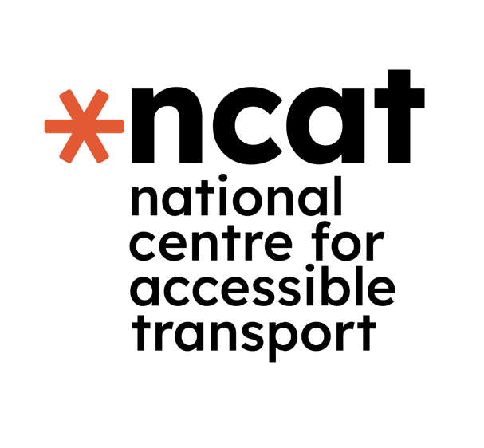
Disabled people in the UK make significantly fewer journeys than non-disabled people, (The Department for Transport National Transport Survey 2024) a gap that has remained largely unchanged for over a decade. This has profound consequences for access to employment, education, healthcare, social connection and participation in everyday life. Despite this inequality, there has historically been no dedicated national body focused on building high-quality, independent evidence on accessible transport.
In 2023, the National Centre for Accessible Transport (ncat) was established to fill this gap. Funded through a £20 million, seven-year grant from the Motability Foundation, ncat acts as an independent evidence centre, bringing together research, lived experience and cross-sector collaboration to strengthen understanding of how transport systems are experienced by disabled people and how barriers arise in practice.
Grounded in the social model of disability, ncat works in partnership with disabled people, Disabled People’s Organisations (DPOs), researchers, policymakers, transport authorities, operators and industry. This ensures that evidence reflects lived experience and supports real-world decision-making.
As a national convenor, ncat brings together research, data and insight from across the transport system to complement and strengthen existing expertise. Its role is not to duplicate work already taking place, but to connect knowledge, identify evidence gaps and support more informed, consistent and accountable approaches to accessibility in policy, design, delivery and investment across the UK.

Our funder, the Motability Foundation

The Motability Foundation is an independent charity set up in 1977 that is building a future where all disabled people have the transport options to make the journeys they choose.
It supports disabled people in the UK to get around through research, funding and innovation, and oversees the Motability Scheme. The Foundation also awards grants to organisations improving or advocating for accessible transport, working with disabled people, government and industry to build transport equity.
ncat is funded by the Motability Foundation. With this support, ncat provides the evidence base needed to make transport more accessible for everyone.

CEO of Motability Foundation, Nigel Fletcher, said:
“Accessible transport is fundamental to independence, opportunity and participation, yet too many disabled people are still prevented from making the journeys they choose. At the Motability Foundation, our work is driven by a simple but powerful aim: to build transport equity by addressing the significant travel barriers disabled people face that limit choice, confidence and freedom. This is why we fund, support and invest in innovation and research to close the accessibility gap that remains.
One of the ways we're doing this is through ncat. We made a seven-year commitment to establish the centre to fill a critical gap by bringing together robust evidence and disabled peoples lived experience. This report shows the value of that approach. By combining research, lived experience and collaboration across the transport and policy sectors, ncat is helping lay the foundations for more consistent, informed and accountable action on accessibility.
We are proud to support its work and to continue supporting the insight, partnerships and innovation needed to make accessible transport the norm rather than the exception.”

Our consortium partners & supporters


ncat is supported and delivered by a consortium of organisations bringing together complementary expertise across research, design, policy and transport systems. This includes academic leadership and research from Coventry University; innovation and systems expertise from Connected Places Catapult; human-centred and inclusive design from Designability; policy engagement and parliamentary connectivity from Policy Connect; inclusive, ethical research with disabled people led by the Research Institute for Disabled Consumers (RiDC); and technical transport and infrastructure expertise from WSP.
Together, this partnership ensures that ncat’s work is both methodologically robust and closely connected to policy, design and delivery, enabling evidence to be applied in practice.

Governance and expert input
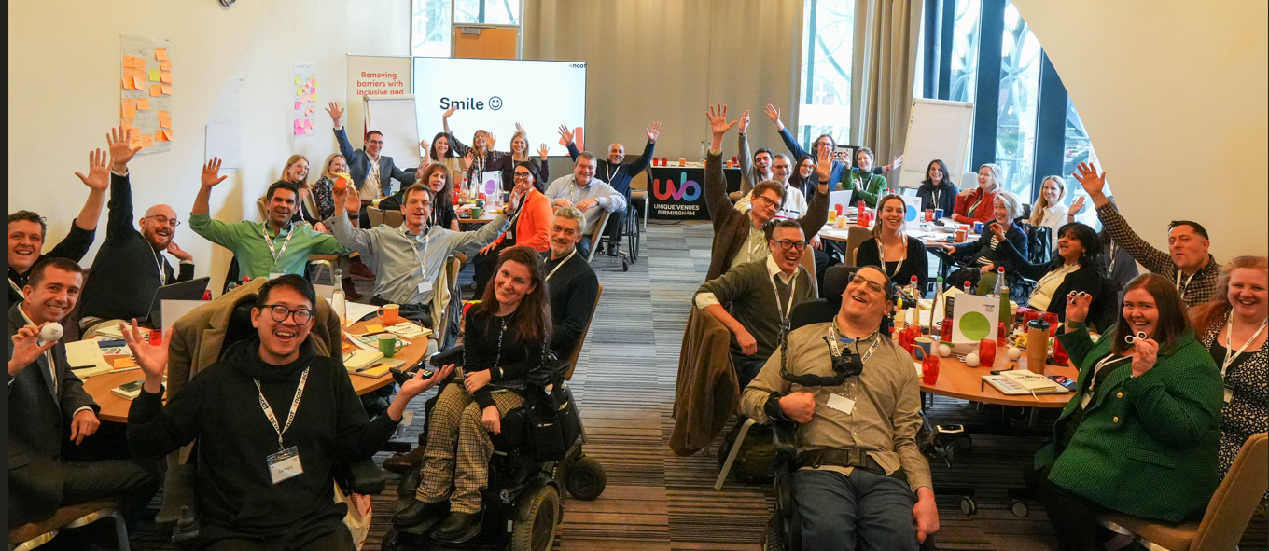
ncat’s work is supported by a governance board and expert panel, providing distinct but complementary roles in oversight, challenge and assurance.
The governance board, chaired by Keith Richards OBE, provides strategic leadership and accountability, bringing together senior expertise from across the sector, including disabled professionals with both lived and professional experience of accessibility. This ensures that ncat’s work is guided by inclusive leadership and reflects a broad range of perspectives.
The expert panel offers independent scrutiny and professional input, members come from DPO’s (Disabled Peoples Organisations) and industry and help to test emerging findings, challenge assumptions and ensure outputs are relevant, credible and decision ready. Together, these structures strengthen the quality, independence and impact of ncat’s work, and reinforce its role as a trusted convenor across the transport system.

Evidence shaped by lived experiences
ncat’s work is grounded in the lived experiences of disabled people through the Community of Accessible Transport (CAT) panel, a UK-wide group providing ongoing insight into how transport works in practice.
The panel is managed by our consortium partner, the Research Institute for Disabled Consumers (RiDC), who ensure inclusive and ethical engagement. Panel members are recognised as experts in their own experience, with appropriate renumeration for their time and contributions.
Over three years, the panel has enabled ncat to generate robust, comparable insight across multiple research programmes, respond to emerging issues, and ensure evidence reflects real-world journeys. It also supports a more coordinated and respectful approach to engagement, strengthening both the quality and credibility of ncat’s evidence.
By embedding lived experience throughout its work, ncat ensures its evidence is not only rigorous, but relevant and actionable for those shaping the transport system.
Adnan, a Community of Accessible Transport Panel Member said:
“I joined the CAT Panel because it's the best way to make things better and contribute as a person with a disability. I would suggest to people who are struggling, come and share your experiences. Contribute and make everything better for everyone.”

Shail, a Community of Accessible Transport Panel Member said:
“The CAT Panel is important because it's about grounding the project in issues. It would be great if more disabled people sign up because everyone's experiences are different.”

ncat impact
Through research programmes, surveys and engagement activities, ncat has worked with disabled people, policymakers and the transport sector to better understand how accessibility is experienced across the whole journey.
Across the research programmes:
- 7,733 disabled people participated in national surveys
- 3,400+ people joined the Community of Accessible Transport (CAT) panel
- 8,600+ people contributed to research and engagement activities
- 17 major research outputs explored accessibility across the transport system.

Linking evidence to policy and practice
ncat has strengthened the connection between evidence, policy and practice through the Accessible Transport Policy Commission (ATPC), a cross-party forum chaired by Baroness Tanni Grey-Thompson. The Commission provides a trusted space for dialogue between disabled people, policymakers, regulators and industry, bringing together lived experience and professional insight to examine systemic barriers.
Through 10 parliamentary and policy events, alongside ongoing engagement, it has supported more coherent discussion of accountability, standards and governance, helping ensure that evidence informs decision-making without prescribing solutions.
This work responds to a consistent finding across ncat’s research: accessibility is often shaped upstream by fragmented governance, unclear accountability and competing delivery pressures. As a result, barriers experienced at the point of travel are frequently the cumulative effect of disconnected decisions across the system.

As Baroness Tanni Grey-Thompson reflected:
“It has been a pleasure to chair ncat's Accessible Transport Policy Commission over the past three years. In that time, I have seen the Commission grow into an influential forum, bringing together key stakeholders and using insights from ncat's research, as well as the experiences and expertise of disabled people and transport professionals, to advocate for policies that will improve access to transport. I look forward to continuing to work with the Commission and the wider ncat to help put evidence at the heart of transport decision-making and ensure that disabled people's voices are heard by those involved in shaping future transport policy and legislation.”
Closing the transport accessibility gap could generate benefits worth an estimated £72.4 billion each year, underlining the significant economic and social value of more inclusive transport systems.

Transport innovations
Scaling Innovation is a multi-million-pound ncat grant programme supporting organisations across transport, technology and design to develop, test and scale solutions that address systemic barriers to accessibility. Delivered with consortium partner Connected Places Catapult, the initiative is grounded in the social model of disability, the programme combines funding with expert academic support, lived experience insight and real testing, supporting projects to move beyond proof of concepts and trials, towards scalable, transferable solutions with practical application.
The programme also strengthens the wider innovation ecosystem by linking funding to evidence generation and shared learning. Insights from funded projects are captured and disseminated across the sector, helping to build collective knowledge and accelerate progress. Impact is reflected in participant feedback, with 100% reporting that the programme supported the development of their product or research, alongside valuable new partnerships with accessibility experts, local authorities and user communities, supporting both innovation and adoption at scale.

Supersmith

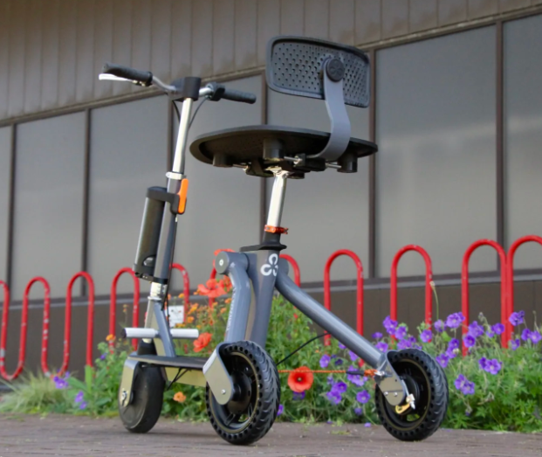
Mobility community innovators Supersmith developed the 3Scooter, a shared micromobility vehicle designed to improve accessibility and independence for disabled people. The project explored how a safe, low-cost, zero-emission vehicle could make shared transport more inclusive for short-distance journeys. Supported by ncat, through the Scaling Innovation programme, the concept was tested with disabled users, who reported feeling safe and confident using the vehicle compared to traditional mobility scooters.
The project demonstrates how involving disabled people in design and testing can support the development of practical, accessible transport innovations.
92% of disabled people report experiencing barriers on at least one mode of transport and nearly half expect accessibility to worsen over the next decade.
Understanding and identifying barriers to accessing transport. The experiences of disabled people in the UK, November 2024.

Journeys across the transport system
Transport journeys rarely consist of a single stage. Instead, they involve a series of interconnected stages, navigating local streets, reaching transport hubs, boarding vehicles, accessing information and receiving assistance when needed. The ability to move seamlessly between these stages is critical, yet for many disabled people this is where journeys break down.
Research conducted through ncat demonstrates that barriers arise across each stage of the journey, and when these barriers combine, travel becomes less predictable, more complex and harder to plan. This reflects a wider systemic issue, that transport in the UK is not accessible.
Across ncat’s evidence, 92% of disabled people report facing barriers on at least one mode of transport, with accessibility ratings remaining consistently low and limited confidence that conditions will improve.
The impacts are significant. 79% of disabled people travel less often as a result of these barriers, many avoid unfamiliar or spontaneous journeys, and journeys are frequently longer, more expensive and more physically and emotionally demanding. These challenges are often compounded by poor integration between transport modes, inaccessible information and inconsistent infrastructure, particularly at points of interchange.
Differences in policy, funding and delivery across the UK further contribute to a fragmented system, creating a postcode lottery in access and experience. These challenges are particularly acute in rural areas, where limited services and infrastructure can make travel significantly more difficult.
Together, this evidence highlights that accessibility is not defined by any single part of the journey, but by how well the system works as a whole. When it does not, the consequences extend beyond transport, affecting independence, confidence and participation in everyday life.

Streetscapes as a barrier to accessible travel
Across ncat’s research, streets and pavements emerge as a significant and often underestimated barrier to accessible travel. The streetscape which includes pavements, crossings and public spaces, forms the starting point of most journeys, and if this first stage is inaccessible, it can prevent journeys from taking place altogether.
Participants consistently identified physical barriers such as poor pavement conditions, pavement parking, street clutter, temporary diversions and inconsistent design. These challenges are widespread, with 87% of participants reporting that pavements are not sufficient for safe and accessible travel.
Beyond physical design, disabled people described the experience of navigating streets as exhausting, unpredictable and often exclusionary. Unplanned disruptions, inconsistent standards and poor communication make journeys difficult to plan, while a lack of consideration in design contributes to a sense that disabled people are expected to adapt to environments not built for them.
Together, these findings highlight that inaccessible streetscapes are not just a design issue, but a systemic barrier that limits independence, access to transport and participation in everyday life.
Streets are often the point at which journeys fail.
97% of disabled people report being forced to travel in the road because pavements are inaccessible.
For many disabled people, barriers in the pedestrian environment mean journeys are avoided altogether, not because transport is unavailable, but because it is unreachable.
The barriers to streetscape access, November 2024

Vehicles, stations and assistance
Accessibility challenges are not limited to infrastructure, they persist across vehicles, stations and the interactions that shape the journey experience. Across ncat’s research, these stages are consistently identified as critical points where journeys can become difficult, disrupted or, in some cases, not possible.
Barriers arise when boarding vehicles, navigating stations and accessing different modes of transport:
- 44% of disabled people report difficulties boarding vehicles
- 56% experience barriers when getting in and out of taxis or private vehicles
- 43% report that step-free access at stations is unreliable or unavailable.
These challenges highlight how physical accessibility remains inconsistent, particularly at key transition points in the journey.
Barriers also continue once on board and at destinations, where design and space constraints can limit comfort and safety:
- 33% report challenges caused by moving vehicles, including lack of handrails or insufficient time to board and alight safely
- 32% report difficulties finding suitable or accessible parking.
Assistance systems, intended to support independent travel, do not always operate reliably:
- 47% report that staff assistance is unavailable, even when it has been booked in advance.
This undermines confidence in the system and makes journeys harder to plan and rely on. Interactions with other people further shape the experience of travel. Accessibility is not only a question of infrastructure, but also of behaviour, awareness and culture:
- 31% report negative attitudes or behaviours from staff or other passengers.
Taken together, these findings show that accessibility depends on a combination of physical design, reliable support and positive interactions.
When any of these elements fail, they can disrupt journeys, reduce confidence and, in some cases, prevent travel altogether. This reinforces a central finding of ncat’s work: accessibility is defined not by the presence of individual features, but by how consistently the system works across the whole journey.
47% of disabled people report that staff assistance is unavailable — even when it has been booked in advance.
Understanding and identifying barriers to transport report, January 2025
“Many of the ‘step free’ platforms still have huge gaps or a small step up to the trains which can cause a lot of anxiety and not all wheelchairs can manage.”
An anonymous research participants experience

Information, data and predictability
Access to reliable information is a critical part of accessible travel. Disabled people depend on accurate, timely and usable data to plan journeys, navigate networks and make decisions with confidence. When information is incomplete or unreliable, it introduces uncertainty that can disrupt or prevent travel altogether.
Across ncat’s research, digital tools are widely used but do not consistently meet accessibility needs:
- 62% of disabled people use websites to plan journeys
- 57% use mobile apps
- 30% rely on friends, family, carers or personal assistants for planning.
The continued reliance on human interventions highlights the gap between the availability of digital tools, and their effectiveness in supporting independent travel.
Participants consistently reported that accessibility information is often missing, inaccurate or difficult to interpret. Across modes, inaccessible and unreliable information emerged as a major barrier. Common issues included:
- live announcements that are inaccessible or unclear
- screens that are difficult to read or inconsistent
- insufficient or delayed information about disruption.
There is also a clear demand for more detailed, real-time accessibility data. Between 22% and 29% of respondents highlighted the need for up-to-date information on factors such as staff assistance availability, priority seating, vehicle overcrowding, accessible toilets, lift operational status, space for mobility aids and the availability of ramps.
These findings point to a wider issue: accessibility is not only about physical infrastructure, but also about the quality and reliability of information that supports decision-making. Standardised approaches to information provision often fail to reflect the needs of disabled people, particularly when journeys involve multiple modes or unexpected disruption.
Predictability is essential for accessible travel. Yet people are repeatedly required to navigate uncertainty around key features such as lifts, assistance and facilities. This lack of consistency undermines confidence, limits independence and, in some cases, leads people to avoid travel entirely.
62% of disabled people use websites to plan journeys, yet many report that accessibility information is incomplete or unreliable.
Understanding and Addressing the Gap in Transport Accessibility Data report, January 2025

Attitudes, behaviour and culture
Accessibility is shaped not only by infrastructure, but by behaviour, awareness and social norms. Across ncat’s research, negative attitudes and interactions are consistently identified as significant barriers to travel, particularly for people with non-visible impairments.
The scale and impact of these experiences is substantial:
- 72% of disabled people have experienced negative attitudes or behaviour in the past five years
- 59% report experiencing this while travelling
- 86% of people with mental health conditions report negative attitudes
- 87% say these experiences impact their daily lives.
These interactions create both practical and emotional barriers. Thirty-one per cent of disabled people report being negatively affected by staff attitudes while travelling, while many describe the fatigue of repeatedly having to justify their needs or explain their impairments. Fear of confrontation can discourage the use of priority seating or requests for assistance, limiting access to support that is intended to enable travel.
Evidence also highlights a gap in public understanding. While willingness to help is often high, awareness is limited:
- only 19% of non-disabled people feel confident identifying someone with an impairment
- 74% demonstrate unconscious bias.
This contributes to what many describe as “invisible barriers” where non-visible disabilities are poorly understood, undermining confidence, dignity and trust in the system.
The impact of these experiences extends beyond individual journeys. Research shows a clear link between inaccessible transport and wellbeing:
- 77% report that transport barriers negatively affect their physical or mental health
- 75% experience stress when travelling
- 60% report reduced confidence
- 87% say barriers limit their independence and choices.
These effects are cumulative, contributing to fatigue, anxiety and social isolation. Taken together, these findings demonstrate that accessibility is not only determined by physical design, but by the behaviours, attitudes and culture that shape how systems are experienced in practice. Infrastructure alone does not guarantee accessibility.
They also reinforce a wider finding across ncat’s work: many barriers experienced at the point of travel are created upstream, through decisions about design, standards, funding and delivery. Persistent issues such as unreliable step-free access (reported by 43% of disabled people) and inconsistent assistance (47%) reflect systemic challenges rather than isolated failures.
59% of disabled people experience negative attitudes while travelling, making behaviour as critical to accessibility as infrastructure.
Invisible barriers report. How public attitudes affect inclusive travel, June 2025

Three years of evidence to inform change
Over its first three years, ncat has demonstrated the value of a dedicated national evidence centre for accessible transport. Its work shows that accessibility is not solely a technical challenge, but one shaped by governance, culture and accountability, where barriers are often created upstream and experienced across the whole journey.
By building a robust, UK-wide evidence base grounded in disabled people’s lived experience, and by bringing together policymakers, industry and communities, ncat has helped create a clearer, shared understanding of where barriers persist and where change is most needed. This work has also highlighted that while knowledge on accessibility exists, it is often fragmented and inconsistently applied, reinforcing the need for a national body to convene, synthesise and strengthen evidence.

Looking ahead
ncat will continue to build on this foundation by developing emerging themes, strengthening its evidence across all four nations of the UK, and working more closely with the transport sector to co-create research. Central to this will be ensuring that lived experience and expertise remain at the heart of all evidence, while continuing to support and refine programmes such as Scaling Innovation to test and develop new approaches.
Together, this work will support more informed, joined up and accountable approaches to accessibility, helping to ensure that transport systems are designed and delivered in ways that work more consistently for everyone.

References and Further Reading

National Centre for Accessible Transport publications
Understanding and Identifying Barriers to Transport: https://www.ncat.uk/projects/understanding-and-identifying-barriers-to-transport/
The Barriers to Streetscape Access:
https://www.ncat.uk/projects/the-barriers-to-streetscape-access-2/
Working Together for Accessible Transport:
https://www.ncat.uk/projects/working-together-for-accessible-transport-2/
Joined Up Policies, Joined Up Journeys:
https://www.ncat.uk/projects/joined-up-policies-joined-up-journeys/
Understanding and Addressing the Gap in Transport Accessibility Data:
https://www.ncat.uk/projects/understanding-and-addressing-the-gap-in-transport-accessibility-data/
Transport Design Decision Making:
https://www.ncat.uk/projects/transport-design-decision-making-2/
Equipping Councils for Change:
https://www.ncat.uk/projects/equipping-councils-for-change/
Economic Benefits of Accessible Transport:
https://www.ncat.uk/projects/economic-benefits-of-accessible-transport/
Scaling Innovation Programme:
https://www.ncat.uk/projects/scaling-innovation/
NCAT Resource Collection:
https://www.ncat.uk/what-we-do/ncat-resource-collection/
Transport Barriers Database:
https://www.ncat.uk/what-we-do/transport-barriers-database/
Community of Accessible Transport Panel:
https://www.ncat.uk/what-we-do/community-of-accessible-transport-panel/
Accessible Transport Policy Commission:
https://www.ncat.uk/what-we-do/accessible-transport-policy-commission/

