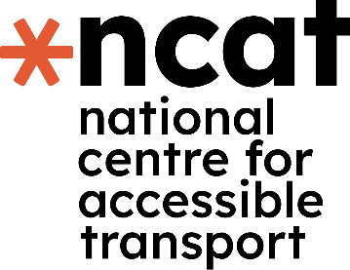

Translating research into design opportunities
Exploring ways to improve accessibility on public transport for disabled people

  - Full Report,
  - October 2025

This report is part of a series of research conducted by the National Centre for Accessible Transport (ncat) since its launch as an Evidence Centre in early 2023. Whilst this report, together with its accompanying Design Opportunities, is standalone, we would recommend it is considered alongside other ncat research published from late 2024. As ncat progresses further, reports and insights will also be published on our website www.ncat.uk
ncat encourage you to freely use the data available in this report for your research, analyses, and publications. When using this data, or quoting any comments, please reference it as follows to acknowledge ncat as the source: ‘ncat (2025). ‘Translating research into design opportunities; Highlighting the ways to improve accessibility on public transport for disabled people’. Available at www.ncat.uk

Highlights
Accessibility is often inconsistent and unpredictable across different types of public transport, creating significant challenges for disabled passengers. This report identifies eight design opportunities where a human-centred design (HCD) approach is recommended to create new solutions to overcome these barriers.
We conducted a programme of discovery research and user engagement to explore the accessibility challenges faced by disabled people when using public transport. The research aimed to understand barriers across different transport modes and identify opportunities for inclusive, human-centred design interventions. HCD solutions are developed by applying design methodology and prioritising users’ needs, experiences, and preferences at every stage of creating products, services, or systems.
Our work focused on key areas: station and stop design, noisy, crowded or bright stations, seating on vehicles, live travel information, and planning and booking journeys. We focused predominantly on buses, overground and underground trains, owing to evidence from the ncat barriers database, as transport modes that are both widely used and most commonly associated with access barriers.
Findings are translated into a set of eight clearly structured design opportunities. This format ensures the insights are accessible and usable by ncat partners, transport authorities, designers, and other sector stakeholders working to improve transport accessibility.
The design opportunities that our research has uncovered can be summarised as follows:
- Bus stop accessibility
Focuses on redesigning bus stops to be universally accessible, predictable, and informative for disabled passengers, by addressing issues like physical barriers to access, unclear information, and unsafe boarding. It highlights how small design flaws, like missing kerbs or a lack of tactile cues, can significantly affect passengers’ autonomy, dignity, and confidence.
- Bus interior flexibility and accessibility
Explores how to redesign bus interiors to be more flexible, intuitive, and inclusive for disabled passengers. It addresses challenges like contested space, inaccessible layouts, and sensory overload, calling for modular, user-centred solutions that prioritise safety and ease of movement.
- Personalising ‘live’ travel information
Focuses on making live travel information more accessible and personalised for disabled passengers by addressing gaps in clarity, format, and delivery. It highlights the need for multi-modal, user-tailored systems that provide reliable, timely updates to support confident and independent travel.
- Train station accessibility
Addresses the need to redesign train stations to be more navigable, predictable, and inclusive for disabled passengers. It focuses on challenges like poor signage, inaccessible facilities, and overwhelming environments, calling for people-centred design that supports safe, independent movement through complex spaces.
- Awareness of diverse travel needs
Explores how to raise public awareness of the diverse and often non-visible access needs of disabled passengers to reduce stigma, misunderstanding, and conflict in public transport. It calls for campaigns that promote empathy, respectful behaviour, and recognition of tools like ‘sunflower lanyards’ to foster a more inclusive and dignified travel culture.
- Clarifying operator-passenger commitments
This design opportunity focuses on building clearer, more transparent commitments between transport operators (e.g. bus drivers, station assistance staff) and disabled passengers to reduce uncertainty, stress, and unmet expectations. It highlights the need for reliable information, defined responsibilities, and mutual trust across both systems and everyday staff interactions, so that disabled people can travel with confidence, knowing operators will deliver on commitments and be accountable when things go wrong.
- Improving existing assistance services
This design opportunity explores how to improve travel assistance services by making them more consistent, visible, and user-driven across all modes of transport. It highlights the need for better integration of technology, clearer processes, and more reliable support, especially from frontline staff, to move from dependency toward autonomy and confidence for disabled passengers.
- Identifying and sharing inclusive transport practices (vehicle, infrastructure, service, etc.)
This design opportunity focuses on identifying and sharing effective inclusive transport design practices and solutions, so that successful solutions don’t remain isolated but become standard across the system. It calls for practical, replicable guidance, grounded in real-world examples, to help transport providers and designers apply what already works with greater consistency and confidence.
We recommend the following actions as the next steps to ensure meaningful progress in public transport accessibility.
Recommendations for transport manufacturers:
- Use the 8 design opportunities as a foundation for creating or improving products, services, infrastructure and user experience.
- Co-design with disabled users to ensure that solutions effectively address real-world barriers.
- Make practical improvements as identified in the design opportunities (e.g. clearer signage, better travel information).
- Plan for long-term changes (e.g. flexible interiors, integrated journeys).
Recommendations for ncat:
- Support further research, focusing on underrepresented groups.
- Share design opportunities to guide future inclusive innovation.
- Lead co-design projects with disabled people and industry.
- Build strong relationships with key transport stakeholders.
- Act as a bridge between users, designers, and providers.
- Expand engagement across all transport modes and regions.

Contents
Highlights 2
Contents 6
1 Why did we do this work? 8
What is the problem? 8
Why did we do this work now? 8
What’s new about this work? 9
What are the limitations of this work? 9
Graph 1. Sex of discovery survey participants (n=482) 11
What’s in the scope of this work, and what’s not in the scope of this work? 12
2 What did we do, how did we do it, and who did we work with? 12
Work package 1: User engagement and evaluation 13
Table 1: Theme areas for exploration during the user engagement 13
Table 2: Transport modes for exploration during the user engagement 16
Discovery survey 18
Select participants for interviews and focus groups 18
Table 5: Recruitment criteria to select participants for interviews and focus groups 19
Who did we engage with? 20
Graph 2: Age of participants (n=50) 21
Graph 3: Sex of participants (n=50) 21
Graph 4: Participant location by UK region (n=50) 22
Graph 5: Participants by impairment type (n=50) 22
Graph 6: Participants by assistive technology, support, or mobility aid (n=50) 23
Individual interviews (online or in-person) 24
Table 6: Who we engaged with in person, about which transport mode and where 24
Table 7: Who did we engage with, about which modes of transport, in online interviews 28
Focus group themes 29
Table 8: Who did we engage with, about which topics, in focus groups 29
How did we analyse the data? 30
Table 9: Categories used to organise potential solution directions 32
Work package 2: Develop design opportunities 32
3 What did we find? 34
Survey results 34
Table 3: Key barriers by research theme area and number and proportion of respondents who found the theme area difficult or very difficult 34
Table 4: Proportion and number of participants rating the use of underground/metro, overground trains and buses “difficult” or “very difficult” by theme area 38
Key design opportunities and insights from user engagement 39
Cross-cutting Themes 46
4 What conclusions did we come to? 46
5 What should happen next? 48
Recommendations for transport manufacturers 48
Recommendations for ncat 49
6 About ncat 50
7 References 51
8 Terms used in this report 52
9 Appendices 54
Appendix 1: Survey questions 54
Appendix 2: Demographics of who we engaged with 60

1 Why did we do this work?

What is the problem?
We wanted to understand the accessibility barriers experienced by disabled people across different types of public transport, where there is also an opportunity to use a human-centred design (HCD) approach to create new solutions to overcome these barriers. This is a design methodology that prioritises users’ needs, experiences, and preferences at every stage of the design, development and implementation of new products, services, or systems. Building on foundational research conducted by ncat, our project explored the everyday realities of disabled travellers.
Accessibility is often inconsistent and fragmented across different types of public transport, creating significant challenges for disabled passengers. While physical infrastructure plays a critical role, barriers also arise from emotional, social, and informational aspects of the journey. Failure to address this range of experiences can limit disabled people’s ability to travel with independence, confidence, and dignity.

Why did we do this work now?
Recent foundational research by ncat, particularly the extensive data from the Understanding and identifying barriers to transport study, has provided valuable data on key accessibility challenges. From here, we now have the opportunity to translate these findings into practical, human-centred design solutions. Undertaking this work now ensures that findings from recent research are quickly and effectively applied to define opportunities for tangible improvements for disabled travellers.

What’s new about this work?
This project goes beyond simply identifying barriers. We have actively engaged disabled passengers, prioritising their direct experiences and insights, to frame the design opportunities – concise, evidence-based statements grounded in lived-experience research that highlight barriers while also pointing to the potential for positive change through design. Our design opportunity documents are structured and non-prescriptive, that define the barriers and users affected, set clear objectives, outline scope and constraints, and highlight opportunity areas without prescribing specific solutions. These documents are intended for transport operators, manufacturers, designers, policymakers, and other stakeholders to address accessibility challenges and explicitly address not only physical accessibility, but also social, emotional, and informational aspects. Each design opportunity document defines a specific accessibility challenge and highlights clear opportunities for improvement. This report captures the methods, findings, and insights gained throughout this work and illustrates how these insights became design opportunities. It highlights the necessity of involving disabled people in co-creating inclusive transport solutions and sets out clear opportunities for both immediate and long-term improvements. Ultimately, this work demonstrates the essential role that HCD can play in creating transport systems that support independence, dignity, and confidence for all passengers.

What are the limitations of this work?
Despite comprehensive participant selection, we identified specific gaps in our user research representation. These were primarily due to the self-selecting nature of the CAT panel and broader design considerations for data collection. The main gaps were:
- Lack of in-person interviews with self-propelling manual wheelchair users
Although 10 self-propelling manual wheelchair users participated in online interviews and focus groups, none were represented in the in-person interviews. The only wheelchair user who took part in the in-person testing sessions was accompanied by an assistant and did not self-propel. However, given the depth and variety of insight gathered through other formats, we concluded this did not significantly compromise our findings.
- No engagement with D/deaf participants
While several participants had significant hearing loss, including lip readers, we did not engage with anyone who is D/deaf. However, open-ended responses collected via the discovery survey from D/deaf participants echoed key accessibility challenges raised in user engagement activities with participants having significant hearing loss, suggesting that the main issues were still captured.
- Limited regional representation
Wales (n = 1), Scotland (n = 1), and Northern Ireland (n = 1) were underrepresented in in-person and interview formats. More participants from these regions participated in the discovery survey, while participants from other regions shared their experiences of travelling across Scotland and Wales. While broader regional diversity would add depth, the core challenges identified are widely applicable.
- Gender imbalance
While overall engagement included 21 men and 29 women, the gender distribution varied slightly across research formats: we engaged with only two men in person, compared to five women. This mirrors the discovery survey panel profile, reflects the self-selecting nature of the CAT panel and stems from prioritising criteria such as impairment type, availability, and mode of transport used. Although full gender balance was not achieved across all formats, this limitation was weighed against other important representational factors.

Graph 1. Sex of discovery survey participants (n=482)
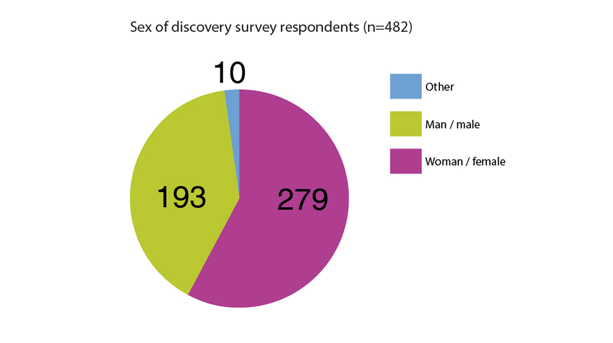
We carefully considered these research gaps and concluded that additional engagement was not necessary at this stage. The insights gathered were both rich and sufficiently diverse to support the development of robust, human-centred design opportunities. We acknowledge that certain gaps, such as the absence of D/deaf participants, underrepresentation from Scotland, Wales, and Northern Ireland, and the absence of non-binary voices alongside a modest overrepresentation of women, may limit the inclusion of some perspectives. We therefore recommend that future research phases or projects focused on gender-specific accessibility issues, D/deaf users, or devolved regional transport systems include dedicated engagement to explore these areas in greater depth.

What’s in the scope of this work, and what’s not in the scope of this work?
In scope:
- Engaging directly with disabled people through survey, interviews, and focus groups focused on prioritised theme areas and modes of public transport
- Developing practical, user-informed design opportunities for transport stakeholders based on lived-experience user research.
Out of scope:
- Policy or regulatory analysis
- Implementation or evaluation of design solutions.

2 What did we do, how did we do it, and who did we work with?
We carried out the following:
- Work package 1 - User engagement and evaluation
Discovery survey, interviews, and focus groups with disabled people to get deeper insights into specific public transport barriers.
- Work package 2 - Develop design opportunities
Creation of design opportunity documents based on lived-experience evidence to inspire innovators and the transport industry, and to inform future projects.

Work package 1: User engagement and evaluation
During the user engagement, we explored five key theme areas, selected due to recurring instances within ncat’s evidence base and wider research, together with the potential to be addressed through human-centred design, to deepen our understanding of disabled people’s experiences when using various modes of public transport:

Table 1: Theme areas for exploration during the user engagement
Theme area | Why included
- Transport station and stop design | - Reported as a barrier by 44.4% of bus users, 28.6% of air travellers, and 28.1% of train users in the ncat dataset.  - The Campaign for Better Transport report highlights good practice but little work with or led by disabled people, indicating a clear opportunity for HCD.
- Noisy, bright or crowded stations | - The NCAT Barriers database³ shows that 14.4% of respondents reported this as a barrier, with disproportionate impact on people with social/behavioural impairments (41%), mental health conditions (39%), and learning disabilities (36%).  - Limited prior applied research makes this a priority for user-led design.
- Seating inside a vehicle  - Comfort of seating  - Availability of seating and dedicated spaces for wheelchair users | - The NCAT Barriers database highlights that 40% of people saw comfort and availability of seating as a key barrier to rail travel.  - No known research on good practice in seating/space design for disabled users on public transport vehicles.
- Live travel information | - 40% of disabled Londoners felt they would use public transport more often if it were easier to obtain travel information.  - The NCAT Barriers database5 highlighted that barriers include on-vehicle information (23%) and inaccessible audio/visual information (21%). Further to this, Transport for All’s report ‘Are we there yet?’ survey with disabled people stated that 37% cited lack of accurate real-time bus information.
- Planning and booking a journey  - Planning journeys using accessible methods  - Booking and paying for journeys | - In Transport for All’s report ‘Are we there yet?’6, a survey found that 36% still rely on printed timetables to plan journeys, even though most respondents completed the survey online, suggesting that internet access alone does not remove barriers to digital planning tools.  - In the NCAT Barriers database5, planning a journey was highlighted as a barrier for 21%.  - Booking and payments were a barrier for 13% of people.  - In Transport for All’s report ‘Are we there yet?’6 survey, booking and payment barriers affected 22% of rail users  - Several respondents to Transport for All’s report ‘Are we there yet?’6 survey stated that they could not travel at all if the ticket office was closed. This could be because navigating the right ticket to buy was too complex or because alternative options, such as ticket vending machines, were inaccessible.  - While disabled people are more likely to travel by bus than other modes of public transport, issues often arise as a result of poor journey planning information

In addition to focusing on these five theme areas, we selected three public transport modes for deeper exploration through user engagement: buses, overground trains, and underground trains. These modes are among the most frequently used and most commonly associated with access barriers, offering strong potential for near-term impact through human-centred design. Given that one quarter of working-age disabled people cite inaccessible transport as a barrier to employment7, focusing on these high-usage modes is most likely to deliver meaningful benefits quickly.

Table 2: Transport modes for exploration during the user engagement
Transport mode | Why included
Overground trains | - In NCAT Barriers database, 91% of respondents reported significant barriers in accessing overground trains, and 52% of respondents said they use this form of transport.  - When travelling by train in the UK, 40% of disabled people often experience issues or difficulties.  - In Innovate UK report ‘Accessible and Inclusive Transport’, 22.1% of people reported using overground trains in the past 6 months.
Underground trains | - In NCAT Barriers database, 86% of respondents reported significant barriers in accessing underground trains.  - From London-based respondents, 64% said they use the underground regularly, indicating its significance in urban mobility8.
Buses | - In NCAT Barriers database¹¹, 90% of respondents reported significant barriers in accessing buses and around 1 in 5 use buses weekly.  - Whilst disabled people are more likely to travel by bus  than other modes of public transport, issues often arise as a result of poor journey planning information⁹.  - Campaign for Better Transport’s report reviewed existing bus stop designs, research, and highlighted best practice, but did not outline any work for or with disabled people. This is seen as a key opportunity area.  - Bus Back Better: National Bus Strategy for England notes that the Government have made a commitment to ensure that government-funded buses deliver greater accessibility (for example, space for a second wheelchair, hearing loops and audio-visual information).

Discovery survey
We developed a discovery survey to get feedback from a wide range of disabled people about their experiences in each of the five theme areas and to find out if they were interested in engaging in further engagement activities.

The survey was distributed through the CAT panel to reach a diverse group of respondents across various impairments, mobility aid usage, and demographic factors, including age, gender, and location within the UK. The survey collected a total of 482 responses.
Respondents rated their experiences and ease of travel in each of the five theme areas, providing open-ended explanations to add context, using the following rating options:
- Very easy
- Easy
- Neutral
- Difficult
- Very difficult
- Not applicable/this is not relevant to me.
We kept the questions broad and the number of questions low to encourage participation (e.g. How easy or difficult is it for you to use transport stations or stops?).

Select participants for interviews and focus groups
The survey also asked participants to indicate their interest in further research and engagement on the emerging themes.
We established recruitment criteria to ensure a diverse and representative group of participants was selected for subsequent research activities, including focus groups, online and in-person interviews. The primary recruitment criteria applied were:

Table 5: Recruitment criteria to select participants for interviews and focus groups
Recruitment criteria | Definition
Relevance of experience | Prioritising respondents who indicated difficulty or significant difficulty across our five shortlisted theme areas: stations/stops design, crowded/noisy environments, vehicle seating, planning journeys, and live travel information.
Research interest and availability | Included only respondents who indicated interest in participating in further research activities and selected one or more available formats (e.g. online interviews, focus groups, in-person sessions). Participants could express interest in all formats or select only those they felt comfortable with.
Participant identity | Ensuring the selection of individuals self-identifying as disabled and explicitly removing respondents who identified primarily as assistants, carers or parents.
Diversity of demographics and experiences | Seeking balanced representation across age, sex/gender, geographic location, type of impairments, ethnicity, and the types of mobility aids used. These characteristics were available for all respondents, and selection was guided by prioritised filtering to ensure relevance and representation within sample size constraints.
Transport mode usage | Prioritising respondents who reported using transport modes relevant to the project focus (bus, train and underground – as primary focus area; tram and coach – as secondary focus area).

To account for changes in availability and ensure target sample sizes were met, approximately twice as many participants were invited as there were places available for each activity. This approach helped maintain strong participation despite occasional cancellations.
To enable participants to engage fully in the research, different methodologies were used to discuss varying experiences. Where possible, focus groups were used to discuss broader themes, whilst interviews were used to gain more in-depth personal experiences.
Whilst the overall response rates to the survey were high (482 respondents), there were some impairment types that had higher rates of representation than others. For instance, 411 respondents reported having a mobility-related impairment. This uneven distribution shaped the composition of our research sample. Many of those who reported having mobility-related impairments also noted having additional impairments, e.g. sensory/cognitive/etc. We invited respondents with multiple impairments to take part in interviews or focus groups to learn about the complexity of their experiences of travelling by public transport first-hand.

Who did we engage with?
We conducted qualitative user engagement activities to deepen our understanding of the experiences of disabled people using public transport and to identify areas where improvements could be made. We engaged a total of 50 participants through various methods, including:
- 7 focus groups (34 participants, 4-6 per group)
- 9 online interviews
- 7 in-person interviews at transport stations.
Participants were carefully selected to ensure diverse representation in terms of demographics and experiences. Graphs 2-6 provide an overview of the participants engaged in this research. For a full breakdown of participant demographics, please refer to Appendix 2.

Graph 2: Age of participants (n=50)
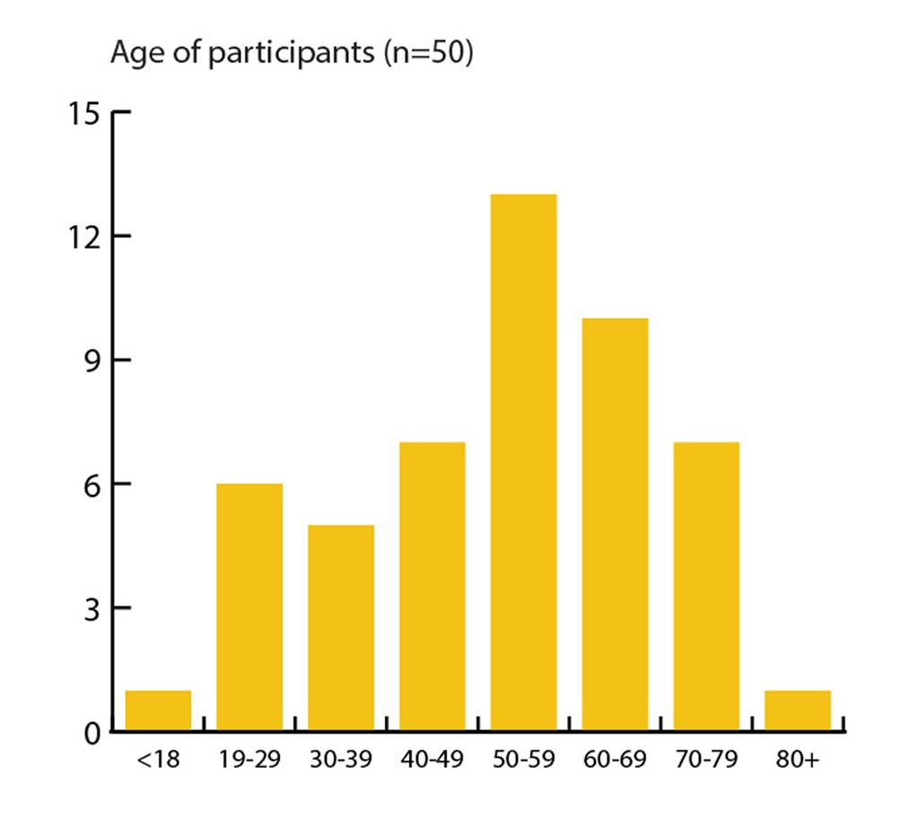

Graph 3: Sex of participants (n=50)
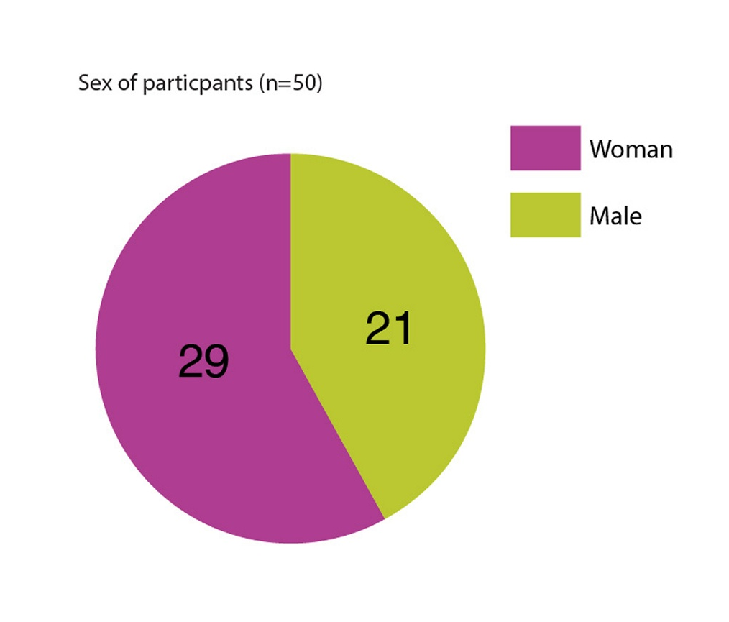

Graph 4: Participant location by UK region (n=50)
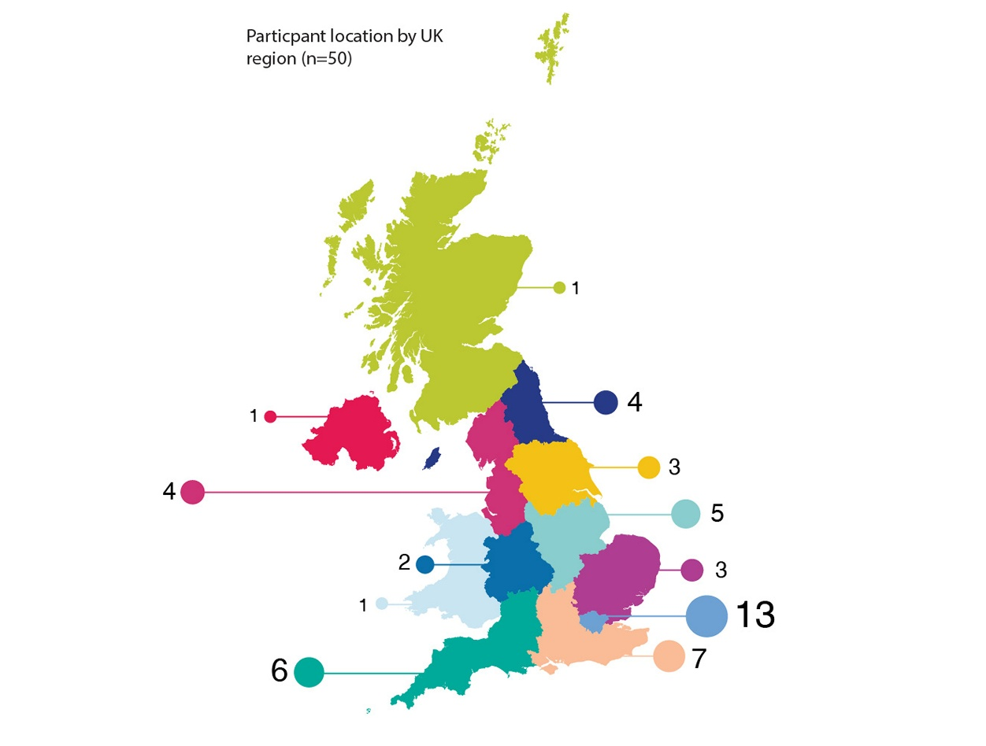

Graph 5: Participants by impairment type (n=50)
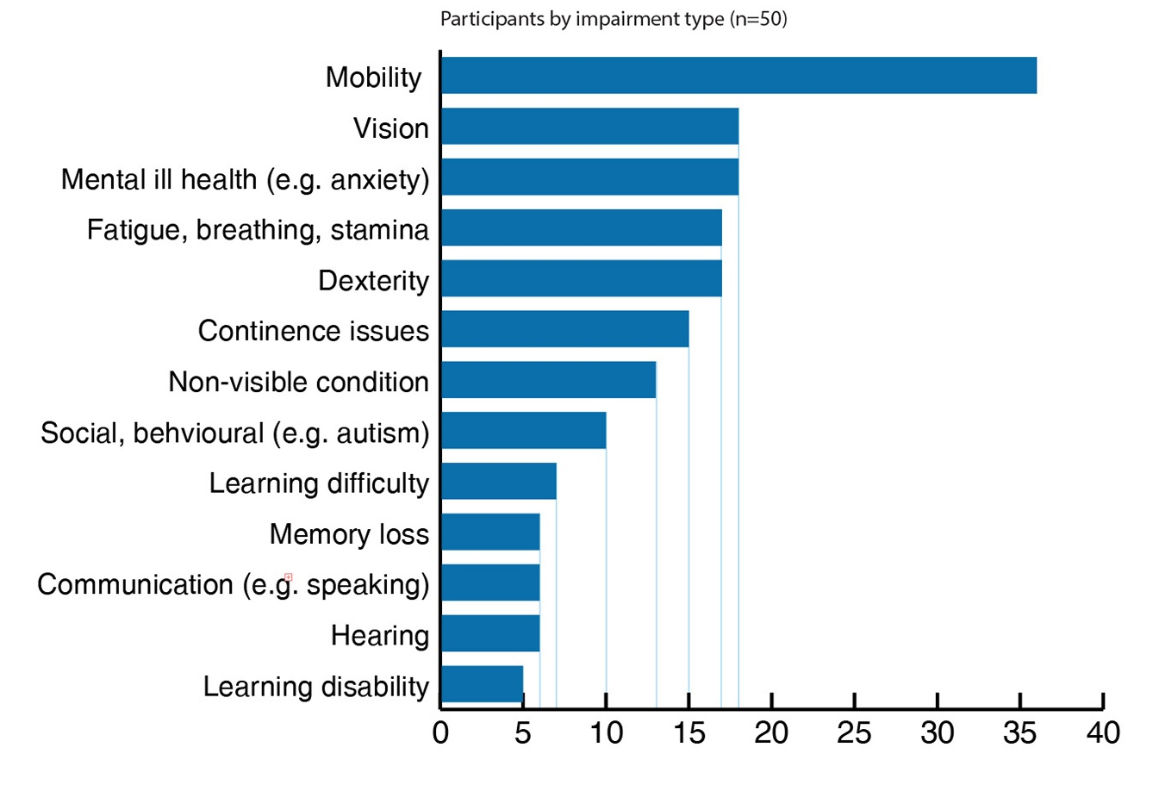

Graph 6: Participants by assistive technology, support, or mobility aid (n=50)
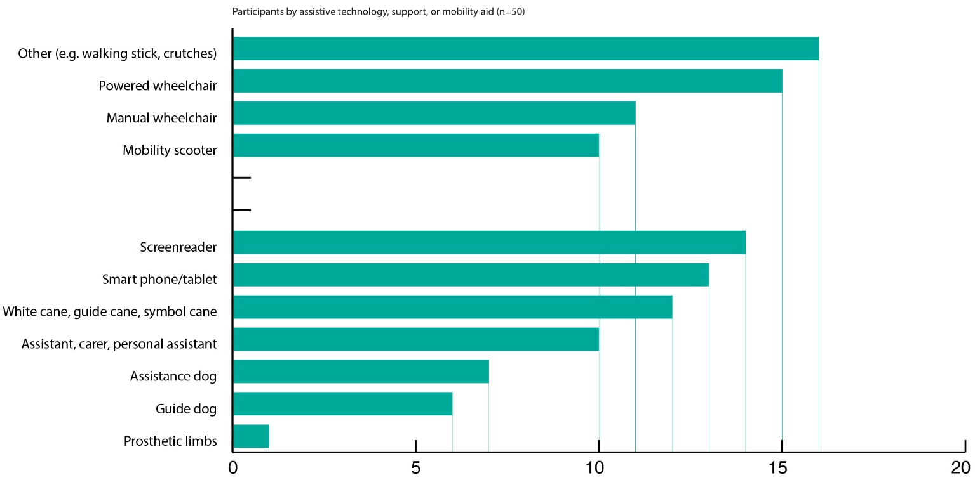
The focus and structure of the interviews and focus groups were shaped by findings from the discovery survey, with topic guides developed based on the five key theme areas identified through the survey analysis.

Individual interviews (online or in-person)
Across the one-to-one interviews (n = 16), participants discussed each of the key theme areas in relation to the modes of public transport they used.
Table 9 outlines the participants who took part in the in-person interviews, where these were conducted, and which transport modes were explored. These interviews took place at or near transport hubs, allowing participants to reflect on their journeys in context and providing us with firsthand examples of the barriers they face.

Table 6: Who we engaged with in person, about which transport mode and where
Research activity | Who | Mode of transport explored | Location
In-person interview 1 | A participant with mobility impairment who uses a manual wheelchair | Overground trains, buses | Bristol Temple Meads train station
In-person interview 2 | A participant with neurodivergence, who experiences chronic pain and sometimes uses crutches | Overground trains, buses | Warminster train station
In-person interview 3 | A participant with mobility impairment, short-term memory issues and anxiety, who uses a mobility scooter | Bus stations and bus stops | Bath bus station and bus stop
In-person interview 4 | A participant with vision impairment, who uses a white cane | Buses, overground and underground trains | Brentford E8 bus stop and Brentford train station
In-person interview 5 | A participant with vision impairment, who has a guide dog | Overground trains, buses | Victoria train station, London
In-person interview 6 | A participant with vision and mobility impairments, who uses a cane and has a guide dog | Overground train stations, bus stops | Exeter St David’s train station and bus stop
In-person interview 7 | A participant with mobility impairment, who uses a walking stick | Overground train stations, bus stops | Exeter St David’s train station and bus stop

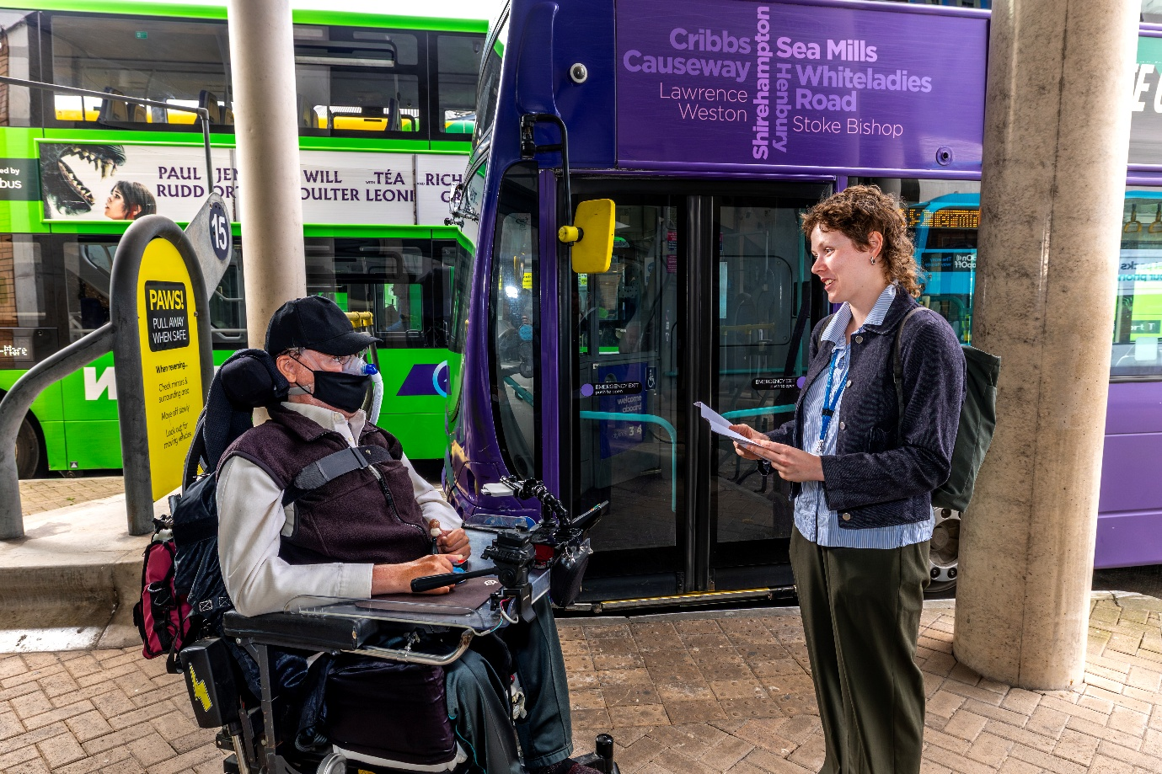
Image 1 - (c) Designability
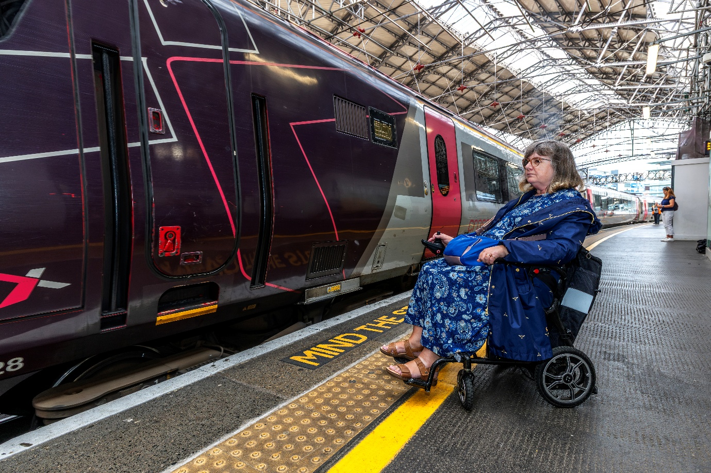
Image 2 - (c) Designability
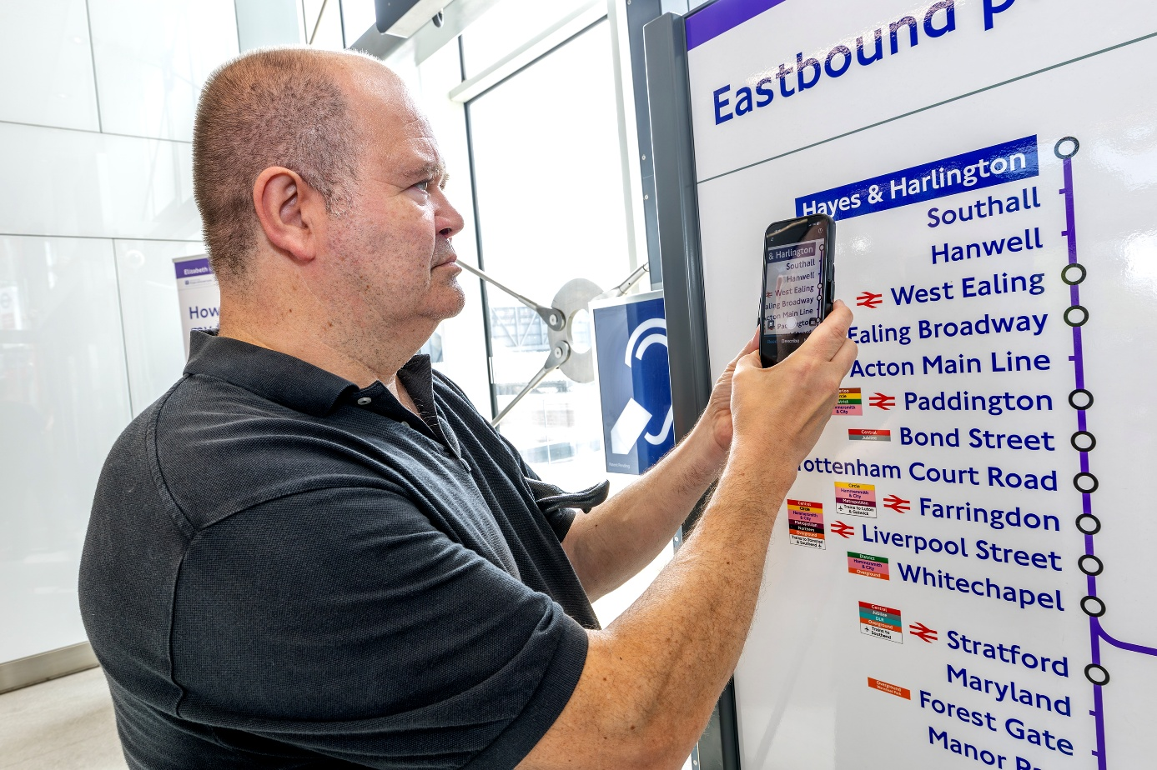
Image 3 - (c) Designability

The nine online interviews enabled us to engage with participants from a broader range of locations than was possible through in-person sessions alone. They allowed us to include a broader range of lived experiences and regional representation, including participants based in the Midlands, Yorkshire and the Humber, and the North East.

Table 7: Who did we engage with, about which modes of transport, in online interviews
Research activity | Who | Mode of transport explored
Online interview 1 | Participant with vision impairment, who has a guide dog and uses a white cane | Overground and underground trains, buses
Online interview 2 | Parent of two disabled children with neurodivergence and learning disabilities | Trains, buses, tube
Online interview 3 | Participant with mobility impairment, who uses a leg calliper and crutches, has arthritis, experiences chronic pain, anxiety and post-traumatic stress disorder | Train stations, bus stations and stops
Online interview 4 | Participant with mobility impairment, who uses a powered wheelchair | Trains, buses, trams
Online interview 5 | Participant with mobility impairment, who uses a manual wheelchair, has prosthetic limbs and hearing loss, experiences memory difficulties and post-traumatic stress disorder | Buses, trams
Online interview 6 | Participant with mobility impairment, who uses a powered wheelchair and has vision impairment | Train stations, bus stops
Online interview 7 | Participant with mobility impairment, who uses a mobility scooter, wheelchair, and walking sticks and is hard of hearing | Trains, buses
Online interview 8 | Participant with mobility impairment, who uses a rollator | Trains, buses
Online interview 9 | Participant with mobility impairment, who uses a mobility scooter | Underground trains

Focus group themes
Each focus group was specifically tailored to explore a particular type of impairment, mode of transport, or emerging theme. For instance, one focus group explored station and stop design with mobility-impaired participants, specifically focused on trains, and another was dedicated to participants with vision impairments, discussing experiences in crowded and noisy environments. A summary of the focus groups is listed here:

Table 8: Who did we engage with, about which topics, in focus groups
Research  activity | Who | Topic for focus group
Online focus group 1 | Participants with a mobility impairment using overground and/or underground trains | Stations/stops design
Online focus group 2 | Participants with a mobility impairment using buses | Stations/stops design
Online focus group 3 | Participants with a vision impairment using buses, overground and/or underground trains | Noisy, crowded or bright stations
Online focus group 4 | Participants with any impairment type and using any mode of public transport | Live travel information
Online focus group 5 | Participants with any impairment type and using any mode of public transport | Seating on vehicles
Online focus group 6 | Participants with any impairment type and using any mode of public transport | Planning and booking journeys
Online focus group 7 | Participants with cognitive and/or sensory impairment (including vision), using any mode of public transport | Stations/stops design

How did we analyse the data?
Capture participant experiences
Each engagement session was documented using observation notes and, if consent was given, audio recordings for online sessions and photos for in-person sessions. All data was then consolidated into a central dataset for thematic analysis.
Consolidating the research data
We reviewed all notes and transcripts to identify recurring patterns and design-relevant challenges. Our synthesis process involved bringing together insights, quotes, and observations from multiple participants to identify common patterns and draw broader conclusions beyond individual accounts. This process involved:
- Coding and tagging quotes to highlight common themes, challenges, or notable experiences
- Organising observations into visual groupings to cluster related data points and surface frequently mentioned barriers and their emotional impact
- Mapping these visual clusters to broader insight areas, allowing us to identify connections between individual experiences and systemic patterns across transport environments.
This iterative process allowed us to transition from raw qualitative data to recurring barriers that could be addressed through human-centred design.

Synthesise insights
To move from the barriers to design opportunities, we grouped our findings into topic areas (different from those identified for the discovery survey), which helped transform rich participant input into:
- Design opportunities that highlighted core barriers while framing potential for positive change
- Insights that reflected underlying needs or motivations
- Opportunity areas where design could make a meaningful impact.
The visual clustering of participant quotes and observations also helped define high-level insight areas and inform the development of initial "How Might We" (HMW) framing questions. These questions were used to explore potential solution directions, many of which emerged directly from user engagement sessions. We categorised these early-stage ideas using the following categories:

Table 9: Categories used to organise potential solution directions
Categories | Definition
Design opportunity | To indicate early-stage ideas with potential to inspire new design concepts
Design guidance | To highlight learnings that should inform or constrain future design work
Quick win | To illustrate changes that may be achievable in the short term with relatively low complexity
Complex system | To show solutions dependent on systemic or multi-stakeholder coordination
These early ideas were not treated as final proposals, but rather as thought starters. They were produced based on the findings and helped inform later decisions around the focus and structure of the design opportunities.

Work package 2: Develop design opportunities
Following the synthesis of research findings and generation of evidence-based insights, we translated the key research findings and emerging challenges into a set of eight design opportunities. Each addresses a specific challenge area related to transport accessibility for disabled people and those with additional access needs.
The opportunities were developed through the following process:
- Cluster insights into themes
We grouped related design opportunities and opportunities emerging from user engagement into distinct challenge themes. (Details of each theme are elaborated in the next section, “What did we find?”)
- Frame each theme as a design opportunity
Each theme was articulated as a high-level “How Might We” (HMW) question to guide design thinking.
- Define objectives and opportunity areas
For each design opportunity, we identified 5-9 objectives grounded in user needs. These were supported by opportunity prompts, such as potential “design fixes”, “quick wins”, “complex systems”, or “design guidance”, derived from research insights.
- Develop design opportunity structure
In addition to insights and objectives, each design opportunity includes:
- Target users – primary and secondary audiences, each design opportunity is intended to support
- Design scope and constraints – what is considered in- and out-of-scope for potential design solutions
- Stakeholders – an initial view of key delivery actors (e.g. operators, infrastructure owners, local authorities) whose collaboration would be vital to implement solutions

These supporting sections were included to help delivery partners assess feasibility, prioritise actions, and explore future collaborations.
- Review
Draft opportunities were reviewed by the project team and refined iteratively to ensure clarity, focus, and practical relevance to the ncat delivery partners.
Each design opportunity reflects a combination of the lived experience evidence from disabled participants and opportunities for design and service innovation. A summary introduction to each of the eight design opportunities is provided in the next section.

3 What did we find?

Survey results
Survey questions (see Appendix 1) broadly asked about each of the five theme areas and then prompted respondents to identify with which transport modes they found those barriers most challenging. Options included trains (overground), coaches, trams, underground/metro, taxis, buses, and other. Therefore, the themes were not restricted to any single mode of transport. Using thematic analysis of open-ended responses from the discovery survey, we identified and categorised key themes, experiences, and barriers explicitly articulated by respondents.

Table 3: Key barriers by research theme area and number and proportion of respondents who found the theme area difficult or very difficult
Theme area | Found “difficult” or “very difficult” | Key barriers (no. of respondents)
Stations/stops design | 61%  (295 / 482) | - inadequate boarding infrastructure and accessibility (133)  - lack of on-site assistance (73)  - non-functional or absent lifts or accessibility equipment (65)  - poor signage and information (48)  - poor station layout and environmental conditions (29)  - insufficient seating and waiting facilities (19)  - difficulties with stairs usage (14)  - absence of clear/consistent procedures for vehicle stopping (11)  - navigation challenges (11)
Noisy, crowded, or bright stations | 59%  (286 / 482) | - sensory overload (noise, light, stimuli) (138)  - navigational barriers in crowds (90)  - emotional distress/anxiety (74)  - physical risk and balance issues (53)  - access to information (visual/auditory) (36)  - dependency on assistance (21)  - lack of rest opportunities (e.g. seating, quiet areas, toilet access) (11)
Seating on vehicles | 52%  (248 / 482) | - space constraints for mobility aids (146)  - insufficient available seating and priority allocation (66)  - difficulty locating and reaching accessible seating areas (39)  - ergonomics and comfort issues (28)  - physical obstructions due to layout or fixtures (e.g. poles, tables) (18)  - transfer into/out of seat and manoeuvring difficulties (16)
Live travel information | 24%  (116 / 482) | - barriers to reading or hearing information in physical environments (35)  - inaccurate / not updated information (30)  - accessibility issues in apps/technology (15)  - unavailable or non-functioning live information systems (7)
Planning and booking journeys | 32%  (155 / 482) | - lack of accessibility information or equipment availability (e.g. lifts/toilet status) (37)  - need to plan far in advance to guarantee accessibility (28)  - unreliable assistance and booking services (20)  - difficulties with using digital tools (17)  - booking process complexity (4)

Additional observations made during the thematic analysis include the following:
- Respondents frequently mentioned that crowded, noisy, or bright stations are compounded by a lack of consideration from other passengers
- Respondents frequently mentioned that they feel uncomfortable asking for a seat or asking other passengers to move to give them space
- Some of the responses for the theme on Planning and booking journeys are also relatable to the theme on Live travel information (e.g. lack of accessibility information or equipment availability, difficulty with using digital tools).
Participants were asked to select up to three transport modes where they encountered the most difficulty within each theme area (e.g. “Where do you find difficulties with stations or stops to be most challenging?”). This approach allowed us to gather more granular feedback within the modes we had already identified as priority areas - buses, overground trains, and underground/metro systems - based on previous evidence of widespread use and reported barriers. While this prioritisation helped direct the research, it may have led to under-reporting of barriers experienced across other transport modes. Nonetheless, the survey responses strongly reinforced our initial focus, with buses, overground, and underground trains most frequently identified as “difficult” or “very difficult” modes.

Table 4: Proportion and number of participants rating the use of underground/metro, overground trains and buses “difficult” or “very difficult” by theme area
Theme areas | Underground / Metro | Overground trains | Buses
Stations/stops design (295) | 32%  (93 / 295) | 54%  (158 / 295) | 61%  (181 / 295)
Noisy, crowded, or bright stations (286) | 55%  (157 / 286) | 84%  (240 / 286) | 40%  (113 / 286)
Seating on vehicles (248) | 36%  (89 / 248) | 63%  (157 / 248) | 70%  (173 / 248)
Live travel information (116) | 35%  (40 / 116) | 99%  (115 / 116) | 61%  (71 / 116)
Planning and booking journeys (155) | 31%  (48 / 155) | 54%  (84 / 155) | 36%  (56 / 155)

Key design opportunities and insights from user engagement
The initial discovery survey provided a robust foundation, clearly highlighting recurring challenges that disabled passengers face in using public transport. Our in-depth engagement activities, including interviews, focus groups, and in-person sessions, supplemented these with a more nuanced understanding of these issues. These engagements revealed the extent and variability of barriers, the emotional and practical impacts they create, and users' ideas for change.
Below, we summarise key insights identified across all stages of user engagement, including the survey and qualitative activities, structured according to the challenges covered by our eight design opportunities. Each design opportunity is tagged (#) to indicate the relevant domain, where possible future design solutions may be focused.
- Bus stop accessibility (#Environments)
The survey findings showed that physical barriers (e.g. lack of step-free access or high kerbs), unclear boarding points, and poor information clarity were key issues experienced by disabled people when using bus stops. Key insights from interviews and focus groups:
- Participants shared detailed experiences of confusion and stress related to locating stops, identifying the correct approaching bus, and safely navigating boarding.
- Participants using wheelchairs expressed experiencing anxiety caused by inconsistent boarding points and insufficient space to manoeuvre when boarding a bus or navigating the waiting area.
- Blind and partially sighted participants expressed reliance on auditory cues, which were often unreliable or entirely absent, significantly increasing their uncertainty and travel anxiety.
“When it's not a designated bus stop, and the driver just pulls up somewhere random, that’s really hard. I never know where the door will open or if there’s space to get on.” (Participant with mobility impairment using manual wheelchair)
- Bus interior flexibility and accessibility (#Vehicles/modes)
The survey findings showed that crowded or contested spaces, insufficient wheelchair areas, and unclear priority seating were key issues experienced by disabled people when using buses.
Key insights from interviews and focus groups:
- Research participants highlighted physical and emotional challenges caused by inflexible bus interiors.
- Participants using wheelchairs or other mobility aids often had to compete for limited space with prams, sometimes facing confrontation or being forced to wait for the next bus.
- Blind and partially sighted participants described how inconsistent layouts and a lack of clear tactile or audio cues made it difficult to find and reach a suitable seat independently.
- The absence of predictable features across vehicles increased stress and reduced travel confidence.
- Frustration with priority seating, either unclear signage or inconsistent social norms, leading to conflict or hesitation, was widespread.
“The amount of stress I get from getting on a bus and seeing a pram in the wheelchair space is awful. Then you have to have the conversation, and sometimes the drivers won’t back you up.” (Participant with mobility impairment using manual wheelchair)
- Personalising ‘live’ travel information (#Services/experiences)
The survey findings showed that inaccessible live announcements, unclear or unreadable screens, and insufficient information regarding disruptions were key issues experienced by disabled people when accessing ‘live’ travel information. Key insights from interviews and focus groups:
- Participants emphasised the critical importance of personalised, multimodal travel information.
- Standardised information was often inadequate, particularly for vision-impaired and neurodivergent participants.
- Information unreliability and inaccuracy significantly impacted participants' confidence and decision-making, with some avoiding travel altogether.
“I need more than just a screen: I need it spoken, clear, and repeated. I can’t keep up if it flashes past or disappears.” (Blind participant with a guide dog)
- Train station accessibility (#Environments)
The survey findings showed that inaccessible station layouts, poor signage placement, distant facilities, and sensory overload were key issues experienced by disabled people when using train stations.
Key insights from interviews and focus groups:
Widespread navigation and orientation difficulties were reported, especially during peak times or service disruptions.
- Blind and partially sighted participants described having to rely on inconsistent or unavailable staff assistance, due to unclear wayfinding and poor signage visibility.
- Participants using wheelchairs shared frustration with physically inaccessible layouts, particularly the placement of lifts and accessible toilets, which were often poorly signposted, locked, or unavailable due to limited work hours.
- Neurodivergent and sensory-sensitive participants reported feeling overwhelmed by loud noise, bright lighting, and crowded concourses, limiting independent travel.
- Across groups, participants called for clearer, multisensory navigation cues, such as tactile paving, high-contrast signage, sound beacons, and consistent lighting, alongside accessible real-time information, and calmer, more predictable environments that reduce anxiety and improve autonomy.
“There are signs, but they’re high up, small print, and not consistent. I end up walking in circles trying to find where I’m going.” (Participant with low vision and cognitive impairment)
- Awareness of diverse travel needs (#Experiences)
This challenge overlaps with work already being done on inclusive travel culture and public attitudes. For more details, see ncat’s Invisible Barriers: How Public Attitudes Affect Inclusive Travel. The survey findings showed that negative attitudes from the public or transport staff, especially concerning non-visible disabilities were contributing to emotional strain and creating barriers to equitable access and inclusion.
Key insights from interviews and focus groups:
- Participants described the emotional strain of continuously needing to advocate for their access needs, particularly when disabilities are non-visible.
- Feelings of vulnerability, anxiety, and frustration were common when requesting assistance or using priority seating due to fear of confrontation, judgment, or disbelief.
- Participants repeatedly described the exhaustion of justifying their disability to sceptical staff and passengers.
- Misunderstanding of non-visible impairments reinforced isolation, highlighting the need for better public education, an inclusive travel culture, and widespread recognition of discreet signals like sunflower lanyards.
“I wear a sunflower lanyard, but people either ignore it or don’t know what it means. I still have to explain everything from scratch. People assume I’m faking it because they can’t see my disability. It’s exhausting always having to explain myself.” (Participant with autism experiencing chronic pain)
- Clarifying operator-passenger commitments (#Services/experiences)
The survey findings showed that a lack of clarity around what assistance transport providers are expected to deliver was leading to confusion, anxiety, and unmet expectations. Key insights from interviews and focus groups:
- Findings revealed a strong sense of frustration and mistrust stemming from the inconsistent delivery of promised services, particularly Passenger Assistance on trains.
- Participants spoke about the emotional toll of uncertainty, wondering whether assistance would be available, whether facilities would work, or how to act when things went wrong.
- Participants flagged unclear or inconsistent support from bus drivers, such as whether they would deploy ramps, wait until seated, or announce stops.
- Clear, accountable communication about available support and passenger rights was seen as essential to reducing anxiety and improving travel confidence.
“I booked Passenger Assistance, but when I got there, no one knew. I never really know if I’ll get the help I was promised. It’s humiliating.” (Participant with neurological condition using powered wheelchair)
- Improving existing assistance services (#Services/experiences)
The survey findings showed that inconsistent delivery of assistance services, a lack of personalisation, and limited mechanisms for feedback when things went wrong were undermining trust and usability. Key insights from interviews and focus groups:
- Participants voiced frustration with inconsistent and unpredictable assistance, particularly at stations and bus stops.
- Anxiety was often associated with booked support not appearing or staff being unaware of their arrival.
- There was enthusiasm for integrated and inclusive tech-based solutions, such as real-time tracking and journey planning apps, provided these tools were reliable, accessible, and designed to complement rather than replace human support.
- Participants desired more personalised support options and greater consistency across different transport modes.
- Limited accountability and a lack of meaningful feedback mechanisms left many feeling overlooked and powerless when things went wrong.
“If the assistance could be tracked on your phone, like a taxi app, you’d at least know someone is coming. Right now it’s blind hope.” (Participant with limited upper limb mobility using powered wheelchair)
- Identifying and sharing inclusive travel practices (#Resource)
Survey respondents often reported inconsistencies in inclusive design solutions across different regions or transport modes. Key insights from interviews and focus groups:
- Participants experienced frustration with the inconsistent application of inclusive design solutions, even within the same region or transport provider.
- Good practices were often discovered by chance rather than through standardised approaches.
- There was strong support for systematically documenting and standardising best practices as a practical and essential step toward making inclusive transport the norm.
- Involving disabled people in evaluating what works was emphasised as critical to ensure guidance reflects genuine user needs rather than just technical compliance.
“In my town, the buses kneel automatically and say the number aloud. When I visited my sister’s, none of that happened. Why isn’t it the same everywhere?” (Participant with visual impairment and partial hearing loss)

Cross-cutting Themes
Throughout our detailed engagement activities, several recurring themes emerged strongly, highlighting broader systemic issues:
- Inconsistent support and services
Disabled passengers repeatedly expressed anxiety and mistrust stemming from unreliable services, information, and assistance, emphasising the need for more predictable, visible and transparent support systems.
- Anxiety and emotional impact
Emotional challenges such as fear of confrontation, judgment, or uncertainty were as impactful as physical barriers, often deterring disabled people from travelling independently and confidently.
- Personalisation and flexibility
Participants consistently advocated for adaptable, human-centred solutions across physical environments, information delivery, and assistance services. A clear demand emerged for more personalised and responsive transport experiences.

4 What conclusions did we come to?
We conducted a programme of discovery research and user engagement to explore the accessibility challenges faced by disabled people when using public transport. The research aimed to understand barriers across multiple transport modes and identify opportunities for inclusive, human-centred design interventions.
Our work focused on five key areas: station and stop design, noisy, crowded or bright stations, seating on vehicles, live travel information, and planning and booking journeys. We focused predominantly on buses, overground and underground trains, owing to evidence from the ncat barriers database, as transport modes that are both widely used and most commonly associated with access barriers. Trams and coaches were considered a lower priority based on usage patterns, and other public transport modes (e.g. taxis, shared mobility, cycling infrastructure) were not explored in this project.
Discovery survey responses (n = 482) and in-depth engagement with 50 disabled participants revealed that accessibility is not just a matter of infrastructure or policy, but also of everyday experience, shaped by physical design, social interactions, and access to real-time support. Participants described the impact of inconsistency, uncertainty, and poor communication on their confidence and ability to travel independently. They also strongly expressed a desire to co-create solutions, valuing inclusive design processes that reflect lived experience and promote dignity and autonomy.
Our findings demonstrate the value and necessity of deep user engagement. While the discovery survey provided critical initial insights, in-depth qualitative activities supplemented these findings and revealed emotional, social, and practical complexities essential for informing future projects aimed at developing meaningful and inclusive solutions.
Rather than compiling a conventional findings report, we intentionally translated our research into a set of clearly structured design opportunities that support practical application. This format ensures the insights are accessible and usable by ncat partners, transport authorities, designers, and other sector stakeholders working to improve transport accessibility. The full design opportunities are available separately.

The research highlighted the importance of integrated approaches that consider physical environments, digital systems, and the roles of transport staff and services. Specific opportunities emerged for both near-term improvements and longer-term, systemic changes. Taken together, these findings underscore the need to address not just isolated fixes but the wider journey experience.

5 What should happen next?
This project has demonstrated how human-centred design highlights practical opportunities for inclusive innovation. We recommend the following actions as the next steps to ensure meaningful progress in public transport accessibility.

Recommendations for transport manufacturers
- Engage actively with the set of eight design opportunities developed through this research and use these as a foundation for creating or improving products, services, infrastructure and user experience. This includes opportunities focused on awareness, education, and attitudes, which, while not service improvements in the traditional sense, are essential to shaping inclusive and supportive travel environments.
- Prioritise inclusive co-design approaches in product development, involving disabled users directly to ensure that solutions effectively address real-world barriers.
- Implement practical and achievable improvements identified in the design opportunities (e.g. clearer priority seating signage, consistent boarding points, and enhanced live travel information systems).
- Explore longer-term systemic improvements (e.g. flexible interior vehicle layouts; real-time, personalised journey planning tools; and better integration between transport modes within a single journey).

Recommendations for ncat
- Encourage and facilitate further inclusive research to address identified gaps, including dedicated engagement with underrepresented groups such as, for instance, d/Deaf users, self-propelling wheelchair users, and participants from Scotland, Wales, and Northern Ireland.
- Disseminate the design opportunities widely among industry stakeholders, policymakers, and transport operators not as prescriptive solutions, but as a way to ground future innovation in lived experience and real-world evidence.
- Undertake follow-on work to take the design opportunities further, using them as the basis for new collaborative projects with disabled people and industry partners to co-design, prototype, pilot, and scale solutions. These future initiatives should embed disabled people as co-creators from the outset, ensuring that lived experience directly shapes the development of accessible and inclusive transport innovations.
- To take the design opportunities forward into practical implementation, ncat should actively establish and strengthen relationships with key industry stakeholders across the identified challenge areas.
- The design opportunities indicate which stakeholders to prioritise for each challenge area (e.g. bus manufacturers and operators when considering vehicle accessibility and associated infrastructure). Building these connections early will be essential to enable collaborative design, prototyping, piloting, and scaling of solutions. Ncat could play a key role as a convening partner, helping to build bridges between disabled users, designers, and transport providers to support shared understanding and joint innovation efforts.
  - For example, ncat now has attended meetings of the UK Bus Manufacturing Expert Panel including those related to Inclusive Bus Design: Raising the Bar for Bus Accessibility Standards. Expanding and deepening this type of engagement across all relevant transport modes will be critical to achieving long-term impact.
- Support further collaborative research projects that focus on under-represented groups and regional transport systems variations to expand the depth and inclusivity of findings.

6 About ncat
The National Centre for Accessible Transport (ncat) works as an Evidence Centre developing high quality evidence, best practice, and innovative solutions to inform future disability and transport strategy, policy, and practice by:
- Engaging with disabled people to better understand their experiences and co-design solutions
- Amplifying the voices of disabled people in all decision making
- Collaborating widely with all transport stakeholders
- Demonstrating good practice and impact to influence policy
ncat is delivered by a consortium of organisations that includes Coventry University, Policy Connect, The Research Institute for Disabled Consumers (RiDC), Designability, Connected Places Catapult, and WSP. It is funded for seven years from 2023 by the Motability Foundation.
For more information about ncat and its work please visit www.ncat.uk
To contact ncat, either about this report or any other query, please email info@ncat.uk
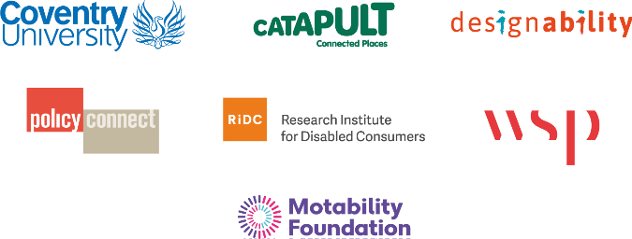

7 References
- Campaign for Better Transport: Better Bus Stops: Creating a national bus stop standard, 2024
- Innovate UK: Accessible and Inclusive Transport, 2023
- Motability: The Transport Accessibility Gap, 2022
- National Centre for Accessible Transport – Transport Barriers Database
- Ncat: Understanding and identifying barriers to transport, 2024
- Transport for All: Are we there yet? 2023
- Department for Transport: Bus Back Better: National Bus Strategy for England, 2021

8 Terms used in this report
Term used in this document | Explanation
Community of Accessible Transport (CAT) panel | A panel predominantly for disabled people, but also assistants, parents and/or carers of disabled children or adults, transport sector workers, members of disability charities, and researchers within higher education institutions. Panel members give key insights and valuable evidence that ncat can use to influence policy and drive change.
D/deaf | An inclusive term used to recognise both Deaf (capitalised ‘D’) individuals who identify as culturally Deaf, often using sign language and participating in Deaf communities, and deaf (lowercase ‘d’) individuals who experience hearing loss but may not associate with Deaf culture or use sign language.
Design opportunity | A concise, evidence-based statement, grounded in lived-experience user research, that highlights a barrier while also framing the potential for positive change through design.
Design opportunity document | Non-prescriptive documents that clearly define specific design opportunities identified through research. Each document outlines a barrier faced by users, sets clear objectives, and suggests opportunities for innovative solutions. They serve as practical guides for designers, transport providers, and policymakers to create products, services, or systems that effectively address identified barriers.
Discovery survey | An initial survey used in research to gather broad insights from a large number of participants typically asks general questions to identify common problems and to select participants with relevant experiences for deeper engagement, such as interviews or focus groups. In this research, the survey helped identify and prioritise the transport accessibility barriers experienced by disabled people.
How Might We (HMW) | A phrase commonly used in design thinking and problem-solving to reframe challenges as opportunities for innovation and ideation.
Human-centred design | A design methodology that prioritises users’ needs, experiences, and preferences at every stage of the design, development and implementation of new products, services, or systems.  It involves actively engaging users, especially those who face the greatest barriers, in research and co-design to ensure solutions are effective, inclusive, and genuinely improve people’s lives.
Multisensory navigation cues | Refers to the use of multiple sensory inputs, including tactile paving, high-contrast signage, sound beacons, and consistent lighting, to support a diverse range of access needs.
Design opportunity | An evidence-based statement that highlights a barrier while framing the potential for positive change through design
Thematic analysis | Thematic analysis is a qualitative research method used to identify, analyse, and report patterns (themes) within qualitative data.
Synthesis  (in the context of qualitative research and human-centred design) | Process of combining, interpreting, and organising data from multiple sources (e.g. interviews, focus groups, observations) to identify patterns, generate insights, and draw meaningful conclusions. It goes beyond summarising individual findings by revealing deeper connections, recurring themes, and systemic issues that can inform the development of design opportunities.

9 Appendices

Appendix 1: Survey questions
Discovery Survey
We would like to ask you a bit about your experiences when travelling.
Consent
Q1) Do you consent to take part in this survey?
Yes, I consent to take part
No, I do not consent
About your travel
Q2) How easy or difficult is it for you to use transport stations or stops?
For example: train stations or bus stops.
- Very easy
- Easy
- Neutral
- Difficult
- Very difficult
- Not applicable/this is not relevant to me.
Q3) Why is this? Feel free to give an example.
Q4) Thinking about the different types of transport you use, where do you find this difficulty with transport stations or stops to be most challenging? (you can select up to three).
- Train (overground)
- Coach
- Tram
- Underground train/metro
- Taxi
- Bus
- Other (please state).
Q5) How easy or difficult is it for you to use noisy, bright or crowded stations?
- Very easy
- Easy
- Neutral
- Difficult
- Very difficult
- Not applicable/this is not relevant to me.
Q6) Why is this? Feel free to give an example.

Q7) Thinking about the different types of transport you use, where do you find this difficulty with noisy, bright or crowded stations to be the most challenging? (you can select up to three).
- Train (overground)
- Coach
- Tram
- Underground train/metro
- Taxi
- Bus
- Other (please state)
Q8) How easy or difficult is it for you to use any public transport seating or seating areas? For example, seating at bus stops and train stations or onboard buses and trains.
- Very easy
- Easy
- Neutral
- Difficult
- Very difficult
- Not applicable/this is not relevant to me.
Q9) Why is this? Feel free to give an example.
Q10) Thinking about the different types of transport you use, where do you find this difficulty with seating or seating areas to be most challenging? (you can select up to three).
- Train (overground)
- Coach
- Tram
- Underground train/metro
- Taxi
- Bus
- Other (please state).
Q11) How easy or difficult is it for you to plan and book a journey?
- Very easy
- Easy
- Neutral
- Difficult
- Very difficult
- Not applicable/this is not relevant to me.
Q12) Why is this? Feel free to give an example.
Q13) Thinking about the different types of transport you use, where do you find this difficulty with planning and booking a journey to be most challenging? (you can select up to three).
- Train (overground)
- Coach
- Tram
- Underground train/metro
- Taxi
- Bus
- Other (please state).
Q14) How easy or difficult is it for you to use live travel information?
- Very easy
- Easy
- Neutral
- Difficult
- Very difficult
- Not applicable/this is not relevant to me.

Q15) Why is this? Feel free to give an example.
Q16) Thinking about the different types of transport you use, where do you find this difficulty with using live travel information to be most challenging? (you can select up to three).
- Train (overground)
- Coach
- Tram
- Underground train/metro
- Taxi
- Bus
- Other (please state).
Taking part
Q17) After this survey, we will select people we think may be suitable for our research and invite them to take part in further activities.
If you take part in one of the research activities after this questionnaire, you will receive £75 as a thank you for your contribution, and we will pay your expenses.
Please note that interviews and group video calls will be 1.5hours long and take place between 9 am and 5 pm, Monday to Friday.
Are you interested in taking part in further research activities for this project?
- Yes / No
Q18) What research activities are you interested in? Please tick all that apply.
- Group online video call
- Online or telephone interview
- In-person interview (this could entail us meeting you at a station or stop, local to you).
Q18) We are conducting research between March and May 2025. Will you be available during this time? (we will offer options of dates/times for research sessions where possible).
- Yes, I am available during this time.
- I have limited availability during this time (please provide more details).
How to contact you
Q19) How would you like to be contacted? (We will contact you by email unless you choose a different option). If you don’t hear from us by the end of April, then unfortunately, you have not been selected to take part in this research.
- I am happy for you to contact me by email
- Please contact me by text first instead, my mobile number is:
- Please contact me by phone call first instead, my phone number is:
Q22) Finally, to thank you for your time spent on this survey, would you like to be entered into the prize draw to win one of five £50 shopping vouchers?
- Yes / No

Appendix 2: Demographics of who we engaged with
People engaged with (captured Wednesday 23rd April, based on who we have and are due to meet up to Wednesday 30th April)
Activity | Focus groups | In-person | Interview | Total
No. of people | 34 | 7 | 9 | 50
Age | Focus groups | In-person | Interview | Total
under 18 (parent) | 0 | 0 | 1 | 1
19-29 | 6 | 0 | 0 | 6
30-39 | 3 | 1 | 1 | 5
40-49 | 7 | 0 | 0 | 7
50-59 | 6 | 2 | 5 | 13
60-69 | 6 | 4 | 0 | 10
70-79 | 6 | 0 | 1 | 7
80+ | 0 | 0 | 1 | 1
Sex | Focus groups | In-person | Interview | Total
Male | 15 | 2 | 4 | 21
Female | 19 | 5 | 5 | 29
Other | 0 | 0 | 0 | 0
Ethnicity | Focus groups | In-person | Interview | Total
White (English, Welsh, Scottish, Northern Irish, British) | 30 | 6 | 8 | 44
Irish | 1 | 0 | 0 | 1
Chinese | 1 | 0 | 0 | 1
Other | 2 | 0 | 0 | 2
Other Asian | 0 | 1 | 1 | 2
Location | Focus group | In-person | Interview | Total
Northwest | 2 | 0 | 2 | 4
Northeast | 4 | 0 | 0 | 4
East of Eng | 3 | 0 | 0 | 3
West Midlands | 2 | 0 | 0 | 2
East Midlands | 4 | 0 | 1 | 5
Greater London | 8 | 2 | 3 | 13
Southeast | 5 | 0 | 2 | 7
Southwest | 1 | 5 | 0 | 6
Yorkshire and Humber | 2 | 0 | 1 | 3
Wales | 1 | 0 | 0 | 1
Scotland | 1 | 0 | 0 | 1
Northern Ireland | 1 | 0 | 0 | 1
Country | Focus Group | In-person | Interview | Total
England | 31 | 7 | 9 | 47
Wales | 1 | 0 | 0 | 1
Northern Ireland | 1 | 0 | 0 | 1
Scotland | 1 | 0 | 0 | 1
Impairment type | Focus Group | In-person | Interview | Total
Mobility | 24 | 5 | 7 | 36
Dexterity | 14 | 3 | 0 | 17
Hearing | 2 | 2 | 2 | 6
Vision | 13 | 3 | 2 | 18
Fatigue, breathing, stamina | 12 | 4 | 1 | 17
Learning disability | 3 | 1 | 1 | 5
Learning difficulty | 6 | 0 | 1 | 7
Social of behavioural (e.g. autism) | 8 | 1 | 1 | 10
Mental ill health (e.g. anxiety) | 12 | 3 | 3 | 18
Memory loss | 5 | 0 | 1 | 6
Communication (e.g. speaking) | 5 | 0 | 1 | 6
Continence issues | 11 | 3 | 1 | 15
Non-visible condition | 11 | 2 | 0 | 13
Mobility Aid | Focus Group | In-person | Interview | Total
Manual wheelchair | 8 | 1 | 2 | 11
Powered wheelchair | 12 | 1 | 2 | 15
Mobility scooter | 5 | 2 | 3 | 10
Other (e.g. walking stick, crutches, prosthetic limb) | 9 | 3 | 4 | 16
Assistive tech/support | Focus Group | In-person | Interview | Total
Guide dog | 3 | 2 | 1 | 6
Assistance dog | 4 | 1 | 2 | 7
White cane, guide cane, symbol cane | 8 | 3 | 1 | 12
Smart phone/tablet | 10 | 3 | 0 | 13
Screen-reader | 10 | 3 | 1 | 14
Assistant, carer, personal assistant | 8 | 1 | 1 | 10
Partially sighted (wears glasses) | 1 | 0 | 0 | 1
Prosthetic limbs | 1 | 0 | 0 | 1
END

Ncat: Understanding and identifying barriers to transport, 2024
National Centre for Accessible Transport – Transport Barriers Database
Campaign for Better Transport: Better Bus Stops: Creating a national bus stop standard, 2024
National Centre for Accessible Transport – Transport Barriers Database
Motability: The Transport Accessibility Gap, 2022
Transport for All: Are we there yet? 2023
Motability: The Transport Accessibility Gap, 2022
National Centre for Accessible Transport – Transport Barriers Database
Motability: The Transport Accessibility Gap, 2022
Innovate UK: Accessible and Inclusive Transport, 2023
National Centre for Accessible Transport – Transport Barriers Database
Campaign for Better Transport: Better Bus Stops: Creating a national bus stop standard, 2024
Department for Transport: Bus Back Better: National Bus Strategy for England, 2021

