**[Insert title]**[Insert subtitle]

[Date]

Transport design decision making

# The experiences of people working in the UK transport design sector

# 

# Highlights Report, November 2024

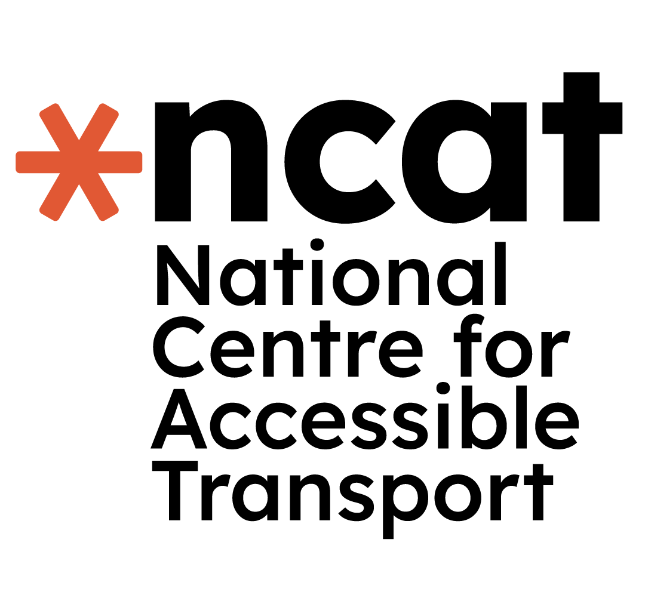

**This report is part of a series of research conducted by the National Centre for Accessible Transport (ncat) since its launch as an Evidence Centre in early 2023. Whilst this is a standalone report, we would recommend it is considered alongside other ncat research published from late 2024. As ncat progresses further, reports and insights will also be published on our website** [**www.ncat.uk**](https://www.ncat.uk)

**ncat encourage you to freely use the data available in this report for your research, analyses, and publications. When using this data, please reference it as follows to acknowledge ncat as the source:**

**ncat (2024). ‘Transport design decision-making’. Available at**[**www.ncat.uk**](https://wsp-uk.shinyapps.io/ncat_dashboard/www.ncat.uk)

## 1 Why did we do this work?

**Disabled people make 38% fewer journeys using transport than non-disabled people. This has not changed for over ten years.[1]**

**In 2023, the National Centre for Accessible Transport (ncat) was set up to help reduce this transport accessibility gap. ncat works with disabled people and people in the transport industry to understand how transport could be improved.**

**To ensure that the National Centre for Accessible Transport is informed by independent views of people working in the transport design sector, an anonymous survey was developed. The survey aimed to find the barriers that people faced that led to design decisions within the sector.**

## 2 What did we do, how did we do it, and who did we work with?

**We designed and created the survey in software called Qualtrics. We wanted to make sure that survey participants could respond easily online. The initial survey design was reviewed and revised, and ethical approval given.**

**The survey was posted on LinkedIn, along with a supporting article (called a 2-minute read). We chose LinkedIn as there is a large professional design and transport sector represented on the platform.**

**Participants provided their consent to take part through an online consent form, after which the participant was anonymised and provided with a further link to access the survey.**

**The survey ran from 15th of November to 15th December 2023, after which the participant responses (data) were collated and analysed. From the data, we established recommendations. At the end of the survey (phase 1), we offered an opportunity for participants to request a follow-up interview (phase 2).**

**A total of 37 people from the transport design sector provided consent to take part in the phase 1 survey. 22 surveys were received as data to review. 2 surveys were excluded as incomplete. The survey included responses from people living in the UK and Australia. Responses were provided by professionals working in senior and early career roles, from the transport sector working on trains and cars.**

**5 people participated in interviews for phase 2 of the study over three months. The interviews were semi-structured but led by the participants. Each participants explained their experiences of working in the transport design sector and the barriers they had faced. We gathered personal stories from across the UK.**

## 3 What did we find?

**Professionals working in the transport design sector described multiple barriers that influence design decision making. These barriers are systemic and become accepted ways of working in the sector. By analysing data, 4 main themes emerged.**

### Theme 1: Decision bias

* **Participants repeatedly refer to decision maker subject bias.**
* **Decisions ultimately remain with the design director or client.**
* **Decision makers who hold senior or long-standing roles, use seniority to ensure ‘their’ solution is carried out.**
* **Acceptance of decisions based upon team leaders ‘knowing the subject best’ and having the casting vote.**
* **No indication of associated design process or expertise in human centred design, ‘they steer the ship in directions they see fit’.**

### Theme 2: Objections

* **The sector has inadequate methods in place to support objections.**
* **Priority of business perspective (time and budget) over user experience preventing better solutions being created.**
* **Claimed ‘audits’ to ensure quality processes around objections are out-dated or incorrectly used to justify credibility of process.**

### Theme 3: Incentive and Guidance

* **Limited incentive for the transport design community to challenge a client’s brief.**
* **Human-centred experiences that teach the ability to engage are limited in the sector.**
* **Limited guidance available to support new designers.**
* **Guidance provided by senior leadership tends to be personal.**
* **Targeted deliverables do not equate to a quality design feedback experience.**

### Theme 4: Collaboration and Participation

* **Cars Collaborative method responses suggest a lack of application of co-creation.**
* **When asked about co-creation tools, participants responded with more traditional methods.**
* **Lack of familiarity with co-creation outside of research or community work – suggesting a sector misunderstanding of the value of co-creation.**
* **There is a lack of ‘space’ to accommodate meaningful collaboration in existing process.**
* **The sector is led by the ‘loudest voices’ – with similarities during the design process.**
* **Hierarchy can result in a design decision barrier regardless of the proposed outcomes.**

**Participants who completed the survey were offered an interview to provide further insight about their experience. The interviews were offered either face to face or online. All 5 participants that requested an interview chose an online format.**

**The interviews were semi-structured. This means we had prepared a series of questions to support the overall discussion, but let the participants lead. As the participants had completed the survey in phase 1, they all shared experience that was similar to the emerging themes.**

**Phase 2 produced data in the form of recorded video and transcripts. To ensure that we were learning new insight, we analysed the data to create an affinity map. This means we found similarities to the phase 1 recommendations and found differences that added to our learning.**

## 4 What conclusions did we come to?

### Conclusions from phase 1 are a combination of themed responses to survey questions and cumulative stories that provided context.

* **Incentivise a design ‘standard’; make this a validation ambition i.e. D-Corp.**
* **Improve knowledge and access to meaningful collaboration methods.**
* **Provide guidance needed to empower new industry talent in relation to accessibility as core knowledge.**
* **Avoid imposing a ‘research’ method as this may risk not being costed into a design project for fear of rejection by clients.**
* **A transparent method of objection is important to enable a responsible outcome not just a single point of view.**
* **Better engagement with experience will provide greater evidence for better decisions.**
* **Complexity of cultural change within design led organisations must be addressed before imposing change.**

### Conclusions from phase 2 are based on cumulative stories that provided context in addition to recommendations of phase 1.

* **Develop mentor support could guide early career designers to progress along their own path.**
* **Review of behaviour in the design community could provide insight into the discipline in practice, and help to define ways to empower design progression beyond bullying.**
* **Improve background research methods for a rigorous and reasoned proposal, to justify and advocate for the solution with confidence.**
* **Provide communication training to improve collaboration with people with disability and empathy.**
* **Develop a transparent validation tool to ensure a better, responsible decision.**
* **Be prepared to challenge a brief, to ensure it is objective and achieves a real ambition.**

## 5 What should happen next?

**The professionals involved in this research experienced numerous barriers that prevented design decisions from being accessible. Their experience translated into a suite of recommendations. We have further considered those recommendations and propose the following steps to improve the system around design decision making in transport.**

**Incentivise a design ‘standard’ as a tool to ensure better, responsible decision making. This might be considered as D-Corp status. This standard could incorporate development of mentor support and much needed guidance to empower new industry talent in relation to accessibility as core knowledge. Establishing an official standard could enable a review of behaviour in the design community in practice, addressing the complexity of cultural change in creative organisations.**

**Establish a democratic relationship in the design decision-making process. A transparent method of objection is important to enable a responsible outcome not just a single point of view.**

**At the outset, challenge the preconceptions of a design brief to ensure it is objective and achieves a real ambition. Achieve this by improving access to meaningful collaboration methods, and background research methods to advocate for validated accessible ambition.**

**Improve engagement with experience for better decisions. Provide communication training to improve collaboration with people with disability and develop empathy skills. Avoid imposing a ‘research’ method as this may risk not being costed into a design project for fear of rejection by clients.**

**Recommendations are also taken up by ncat for its future activities, where ncat will:**

* **use and share these findings to inform future research in conjunction with priorities identified through the voices and experiences of disabled people**
* **work with partners and stakeholders to make these findings available for them to use to robustly evidence the issues faced by disabled people when accessing transport**
* **work with policy makers, transport providers and industry to translate these findings to influence future policy and to develop solutions, products and services to reduce the transport accessibility gap.**

## 6 About ncat

**The National Centre for Accessible Transport (ncat) works as an Evidence Centre developing high quality evidence, best practice, and innovative solutions to inform future disability and transport strategy, policy, and practice by:**

* **Engaging with disabled people to better understand their experiences and co-design solutions**
* **Amplifying the voices of disabled people in all decision making**
* **Collaborating widely with all transport stakeholders**
* **Demonstrating good practice and impact to influence policy.**

**ncat is delivered by a consortium of organisations that includes Coventry University, Policy Connect, The Research Institute for Disabled Consumers (RiDC), Designability, Connected Places Catapult, and WSP. It is funded for seven years by the Motability Foundation.**

**For more information about ncat and its work please visit**[**www.ncat.uk**](https://eur01.safelinks.protection.outlook.com/?url=http%3A%2F%2Fwww.ncat.uk%2F&data=05%7C02%7Carx218%40coventry.ac.uk%7C7c1e3dd1d11d4e0084e208dd04c1f66f%7C4b18ab9a37654abeac7c0e0d398afd4f%7C0%7C0%7C638671953301787456%7CUnknown%7CTWFpbGZsb3d8eyJFbXB0eU1hcGkiOnRydWUsIlYiOiIwLjAuMDAwMCIsIlAiOiJXaW4zMiIsIkFOIjoiTWFpbCIsIldUIjoyfQ%3D%3D%7C0%7C%7C%7C&sdata=iPofW0GnNAWwGPJ3sjs%2BgKNptanInS8%2BN9OEnq8KRUQ%3D&reserved=0)

**To contact ncat, either about this report or any other query, please email**[**info@ncat.uk**](mailto:info@ncat.uk)

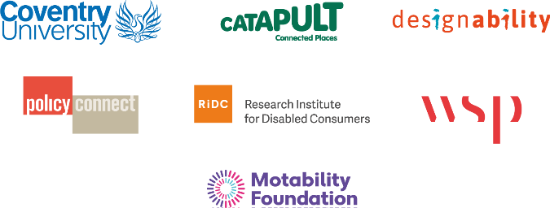

## 7 References

* [**Motability Foundation, The Transport Accessibility Gap The opportunity to improve the accessibility of transport for disabled people. (2022)**](https://www.motabilityfoundation.org.uk/media/iwaidhxk/motability_transport-accessibility-gap-report_march-2022_final.pdf)

1. [**Motability Foundation, The Transport Accessibility Gap The opportunity to improve the accessibility of transport for disabled people. (2022)**](https://www.motabilityfoundation.org.uk/media/iwaidhxk/motability_transport-accessibility-gap-report_march-2022_final.pdf)